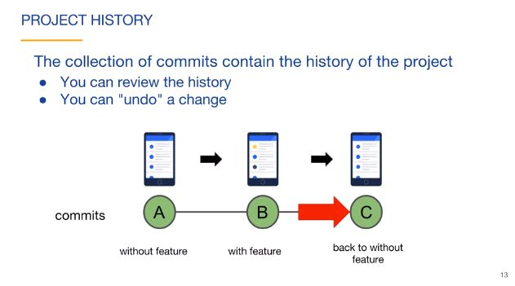

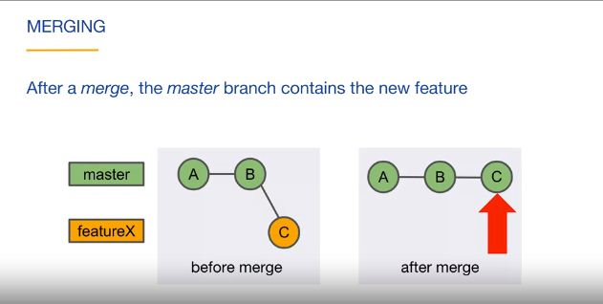

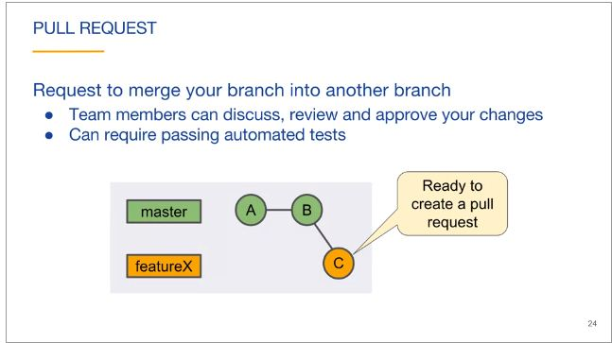

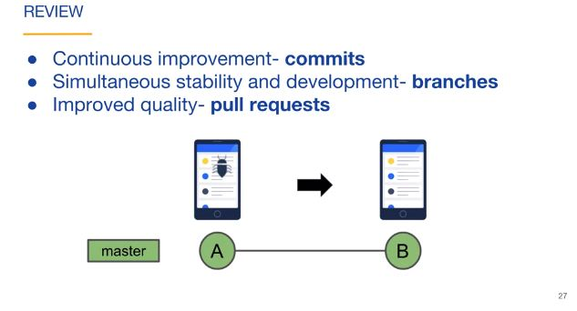

Git Overview

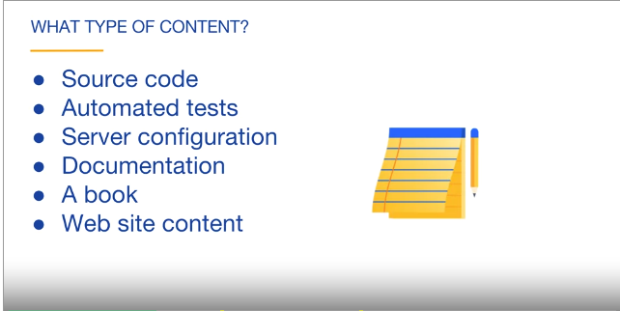

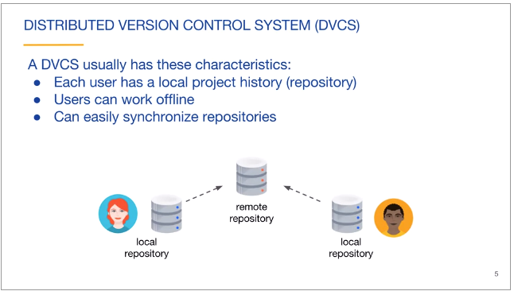

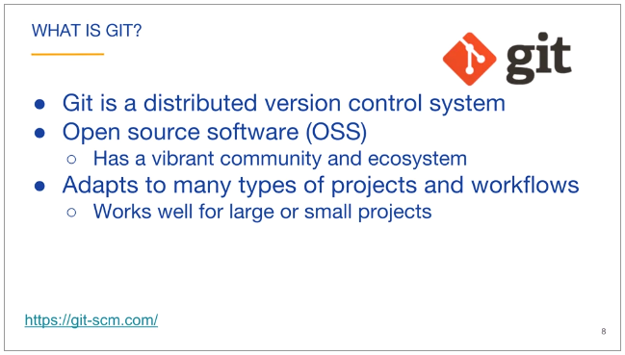

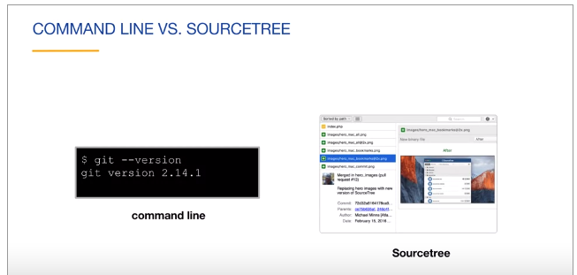

Command line:

The **command line**, also called the Windows **command line**, **command** screen, or text interface, is a user interface that is navigated by typing **commands** at prompts, instead of using the mouse.

A command-line interface processes commands to a computer program in the form of lines of text. The program which handles the interface is called a command-line interpreter or command-line processor.

Source tree:

**Sourcetree** is a free Git desktop client for developers on Windows. Say goodbye to the command line and use the full capabilities of Git through **Sourcetree's** beautifully simple interface .

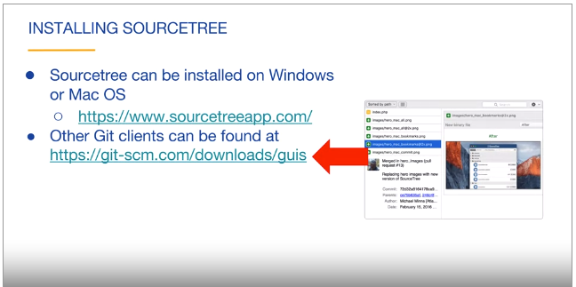

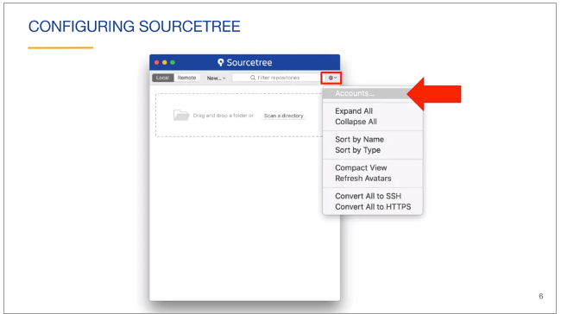

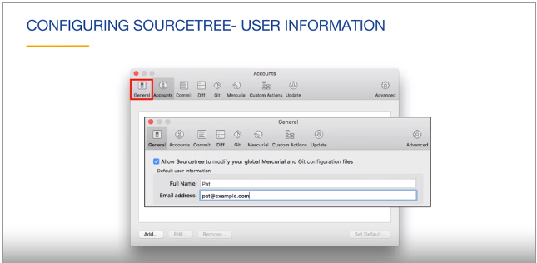

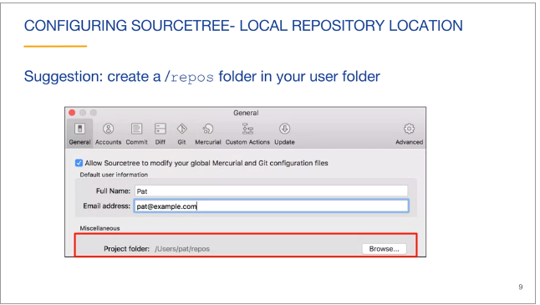

Command Line:

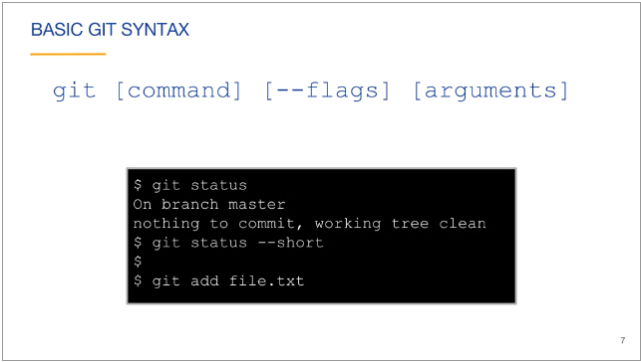

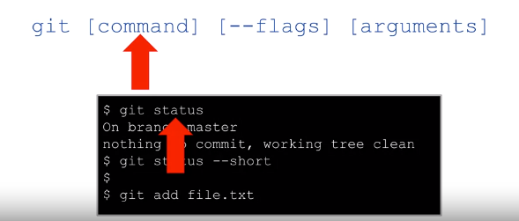

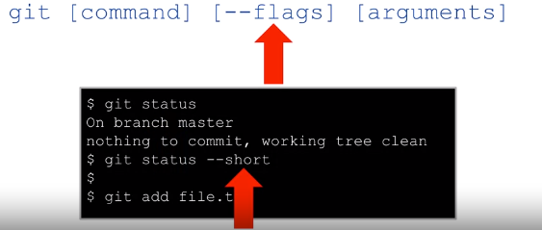

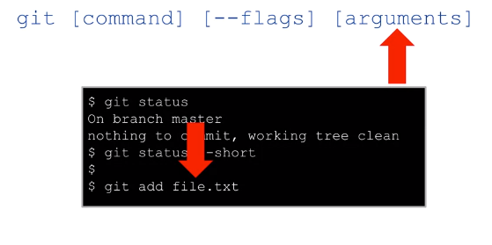

Note: Arguments can be one or more at a time.

* If you confuse about any command use help command to see as docs

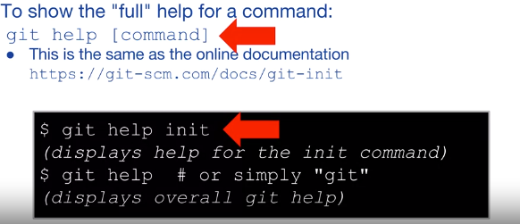

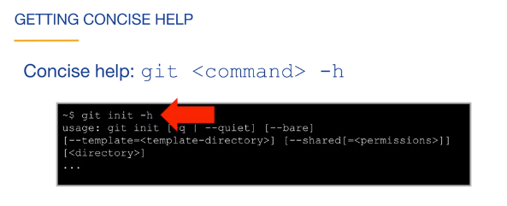

Command line Git symbol meaning:

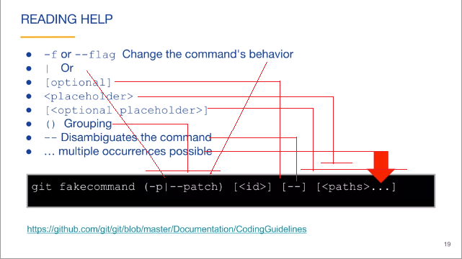

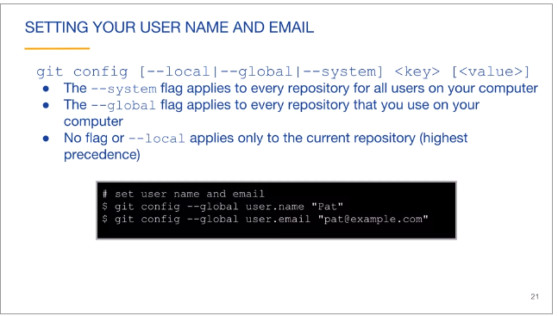

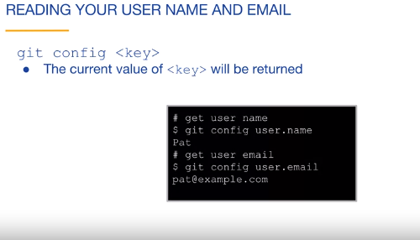

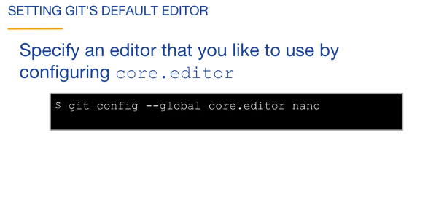

Git Locations

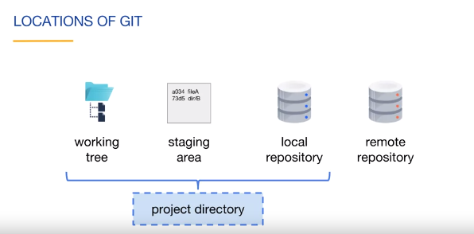

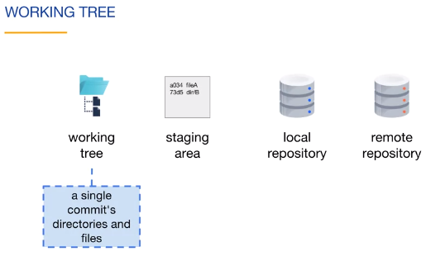

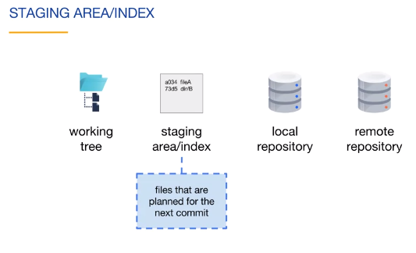

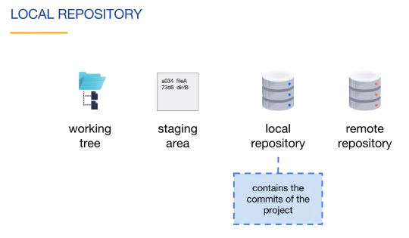

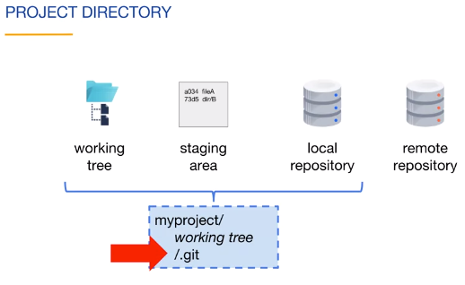

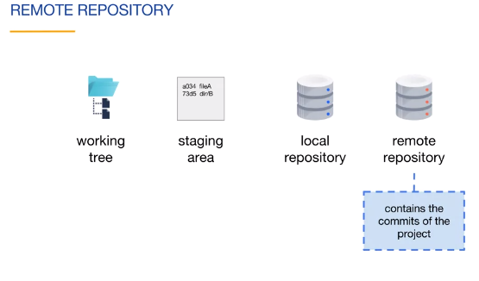

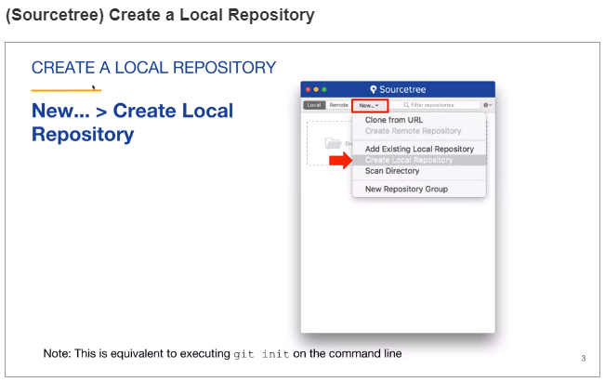

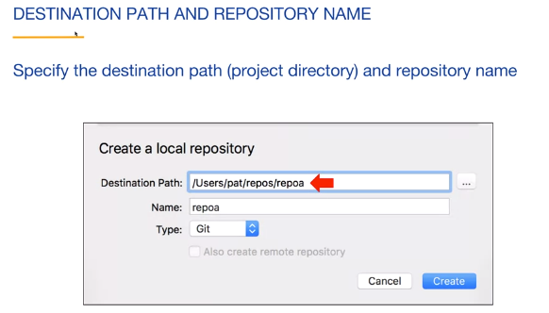

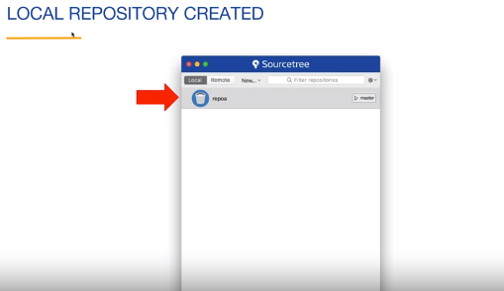

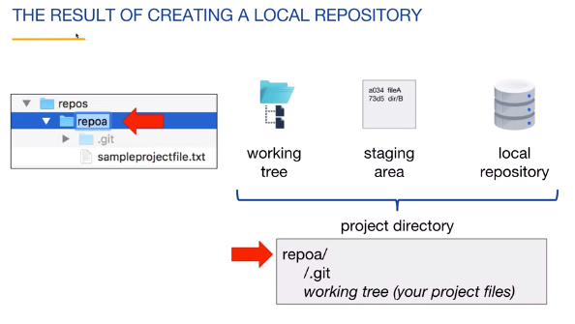

By Command Line :

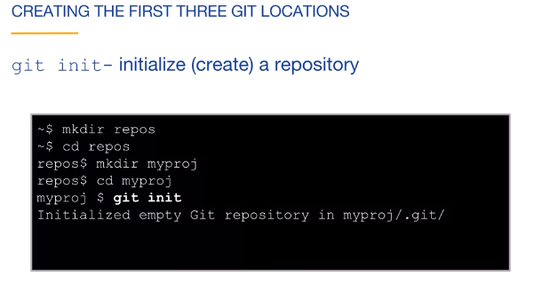

#### (Sourcetree) Commit to a Local Repository

#### 

#### 

#### 

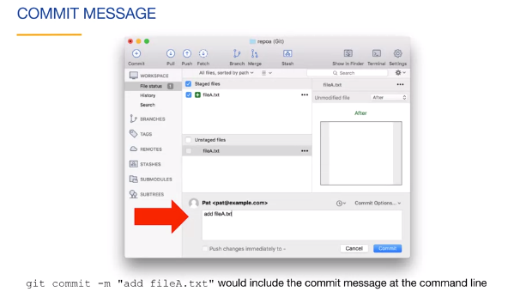

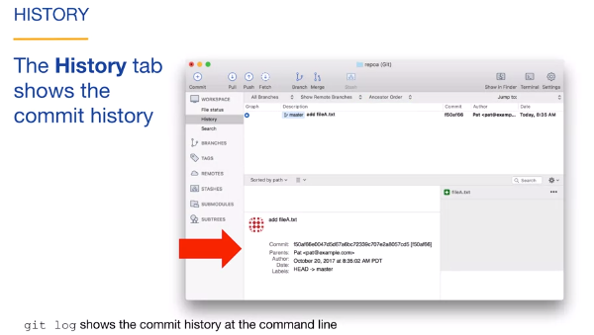

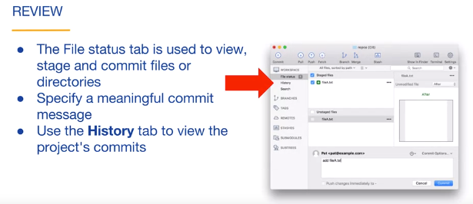

#### (Command Line) Commit to a Local Repository

#### 

#### 

#### 

#### 

#### 

#### 

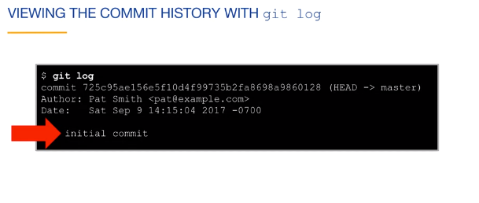

* -- oneline condense version of log
* -# limit the log to the most recent # commits

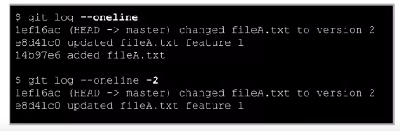

#### Create a Remote Repository

(A remote repository URL usually ends with '.git'.)

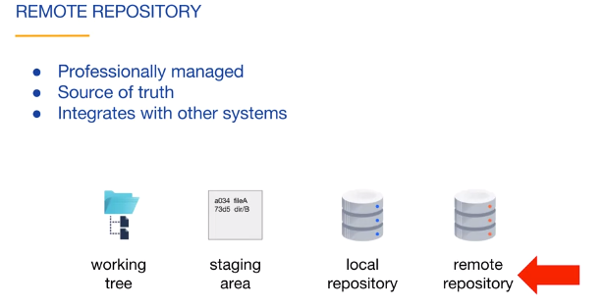

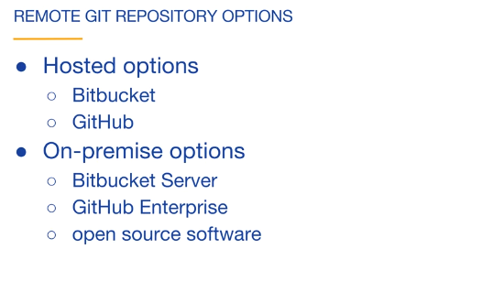

Bitbucket is a web-based version control repository hosting service owned by Atlassian, for source code and development projects that use either Mercurial or Git revision control systems. Bitbucket offers both commercial plans and free accounts.

By- Atlassian

**GitHub** is a Git repository hosting service, but it adds many of its own features. While Git is a command line tool, **GitHub** provides a Web-based graphical interface. It also provides access control and several collaboration features, such as a wikis and basic task management tools for every project.

By -Microsoft

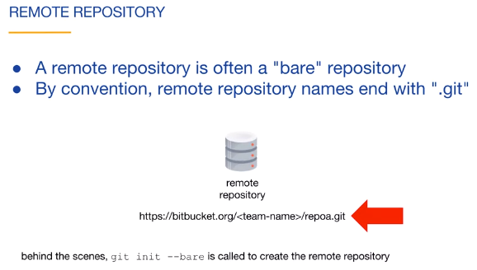

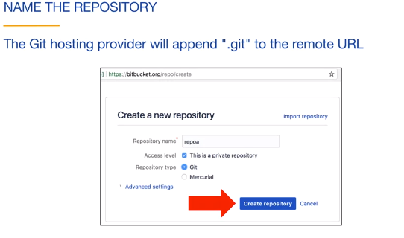

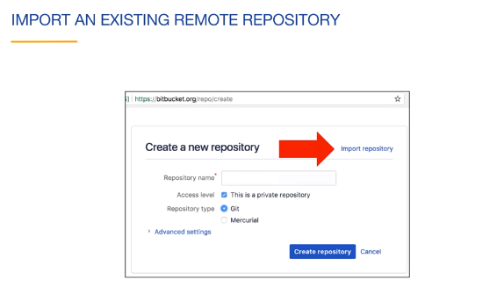

#### (Sourcetree) Push to a Remote Repository

#### 

#### If you have no local repository, where you commited file then you must clone the remote repository of web hosted repository,( bitbucket OR Github). If you have local repository then you just need to add the remote repository of web hosted repository,( bitbucket OR Github).

#### 

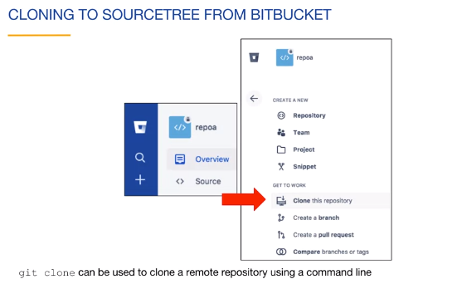

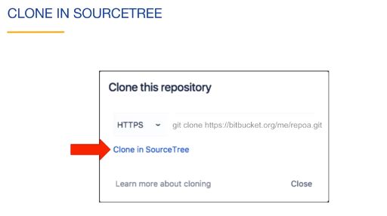

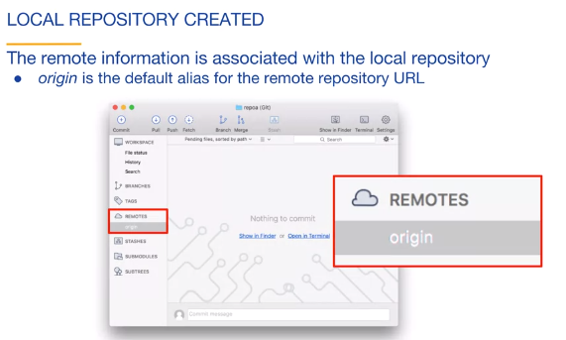

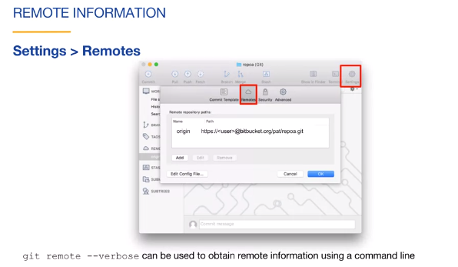

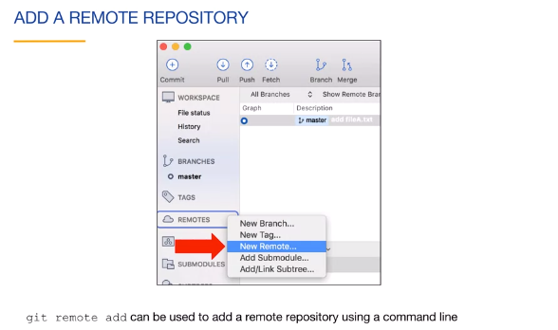

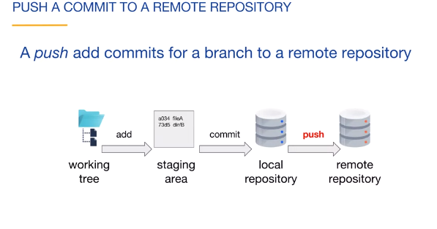

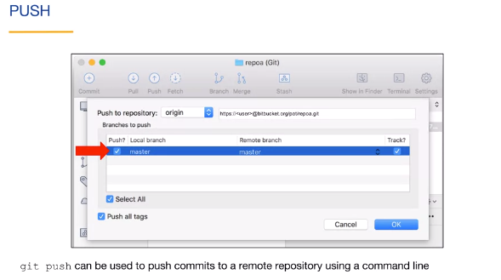

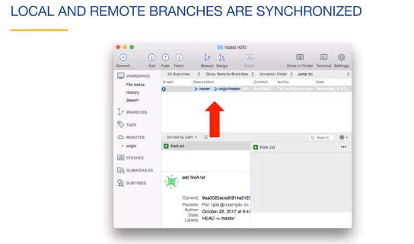

#### (Command Line) Push to a Remote Repository

#### 

#### 

#### 

#### If you have no local repo then you must to clone repo from the remote repository of web hosted repository,( bitbucket OR Github). If you not give [localprojectname]

#### Then clone repo name save as your local repo after that you can perform push opearation.

#### 

#### If you have local repository then you just need to add the remote repository of web hosted repository,( bitbucket OR Github).

#### 

#### 

#### 

#### 

#### Git push –u origin master

#### Where –u track this branch (as master) and origin is as remote repo and master is a branch.

### Branching and Merging I

This module discusses of the key concepts involved with Git: branching and merging. It starts with foundational knowledge on Git's commit graph model, Git IDs and references. Branching and merging are then covered, including the difference between fast-forward merges and using merge commits.

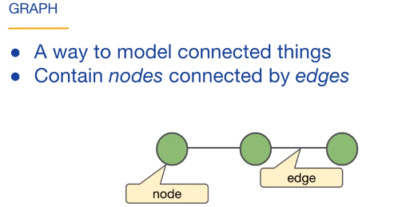

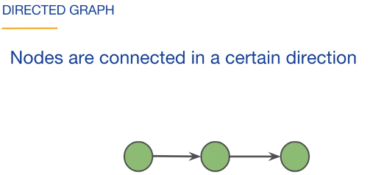

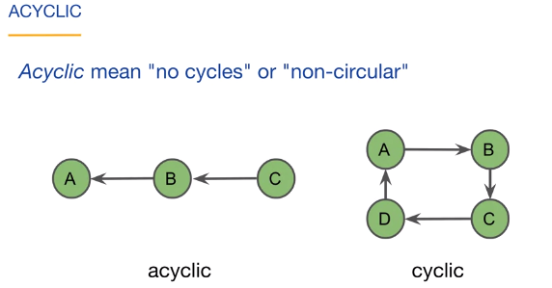

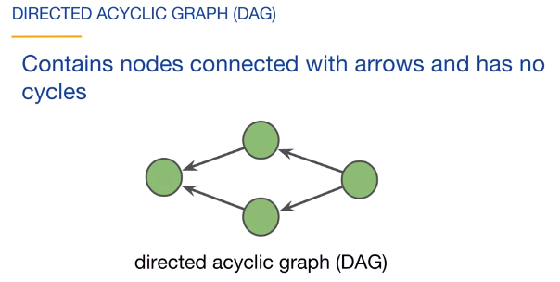

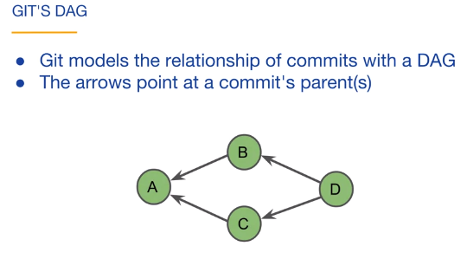

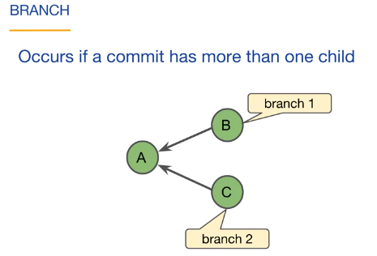

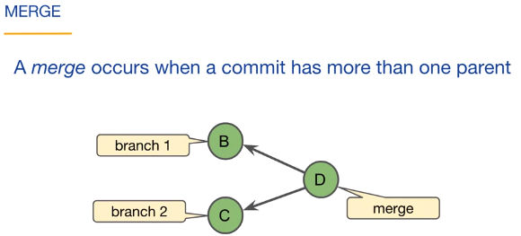

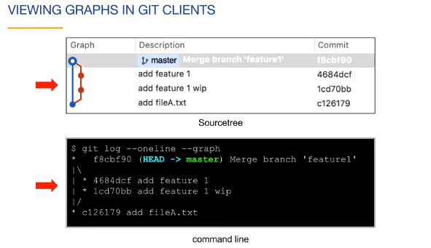

**(Sourcetree) Git IDs**

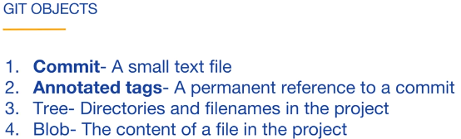

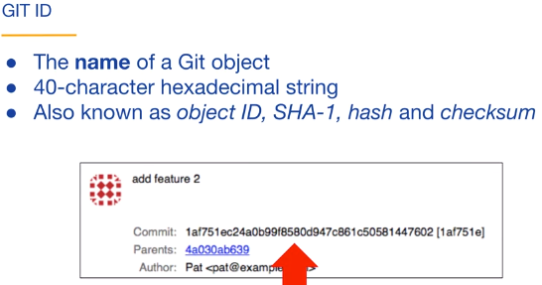

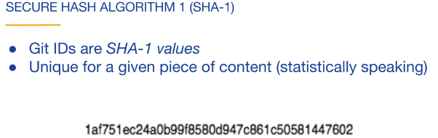

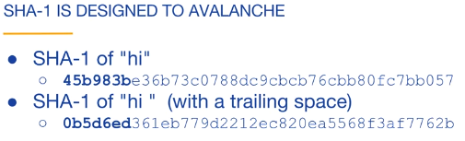

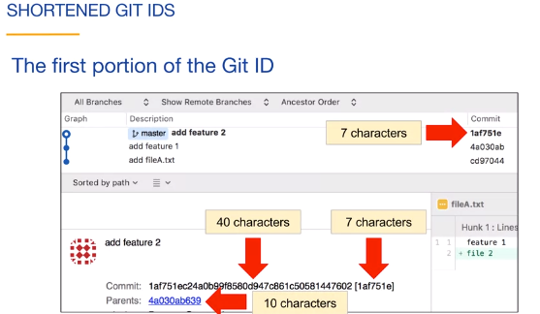

On Command Line:

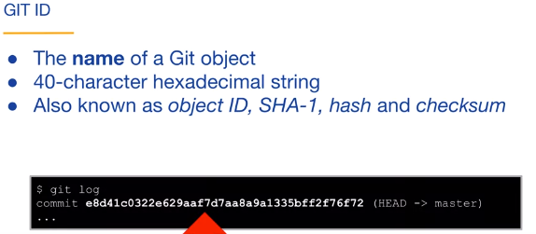

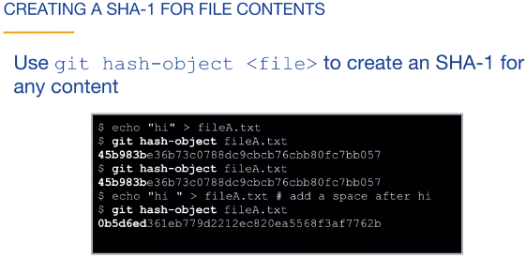

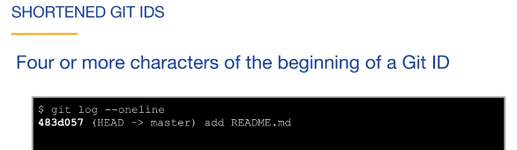

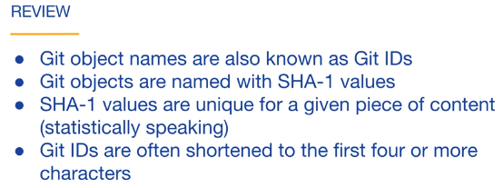

#### (Sourcetree) Git References

#### 

#### 

#### 

HEAD always points to the current commit. *.* Here current commit from master branch so it is label of master branch.

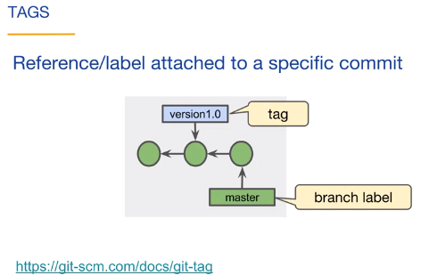

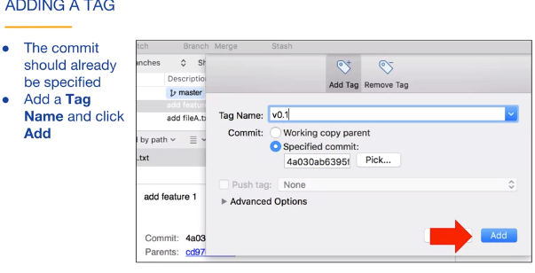

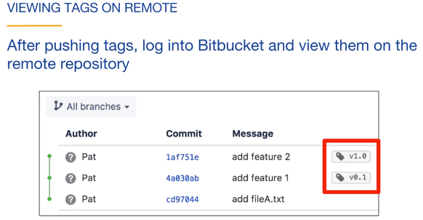

On Command Line:

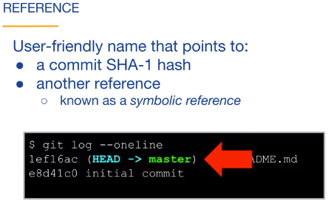

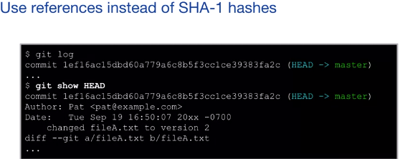

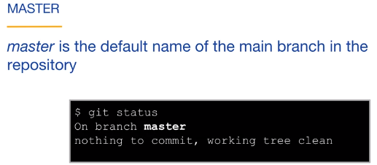

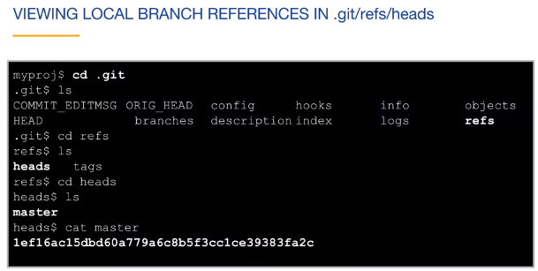

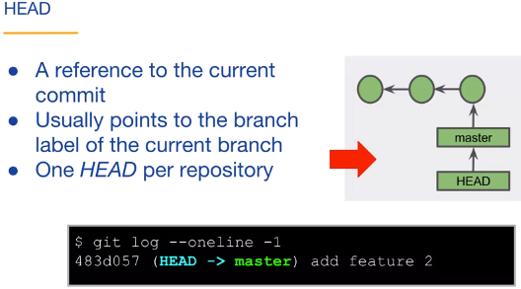

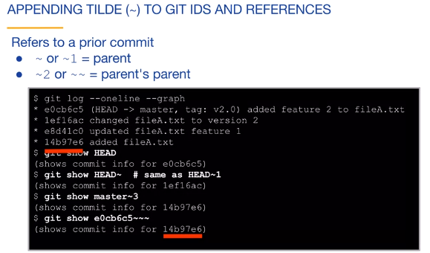

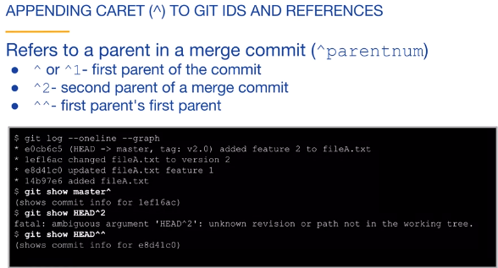

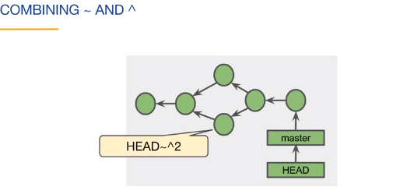

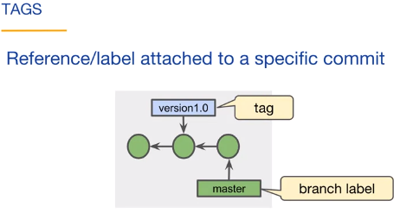

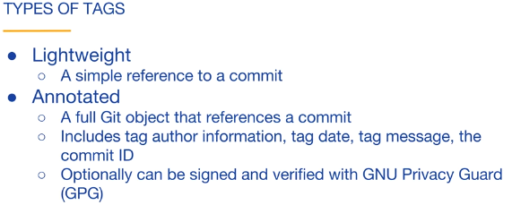

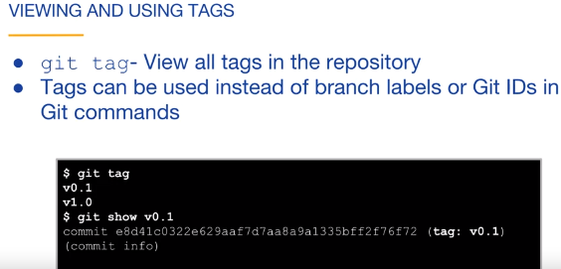

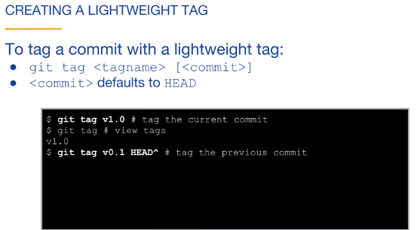

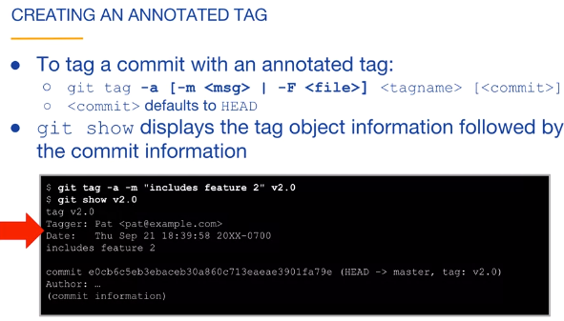

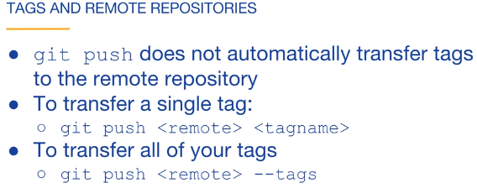

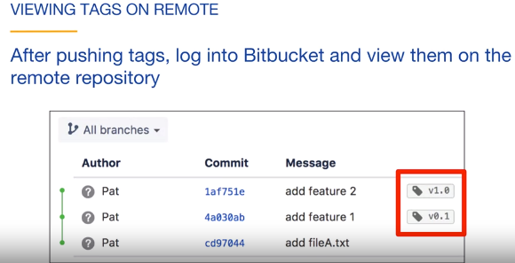

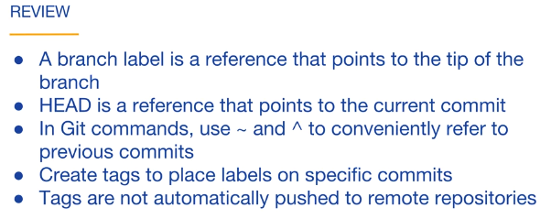

#### (Sourcetree) Branches

#### 

#### 

#### 

#### 

#### ****** ********

#### 

#### 

#### 

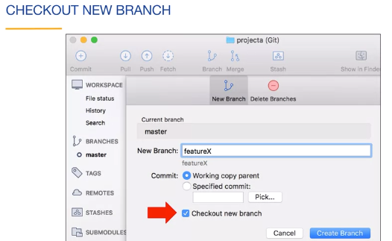

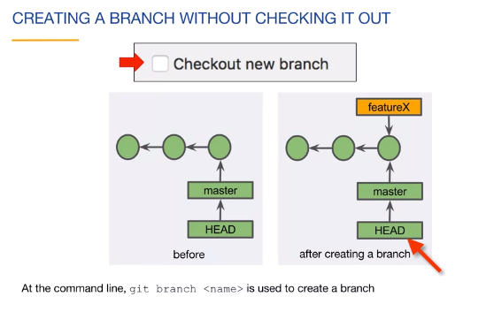 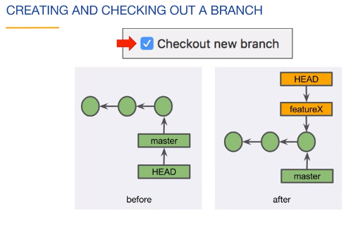

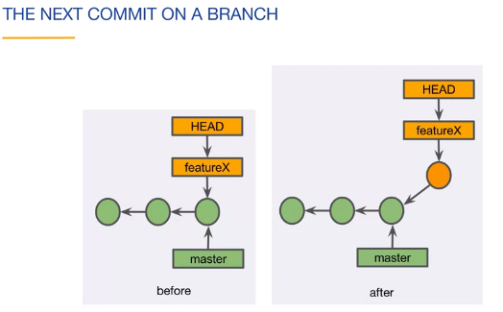

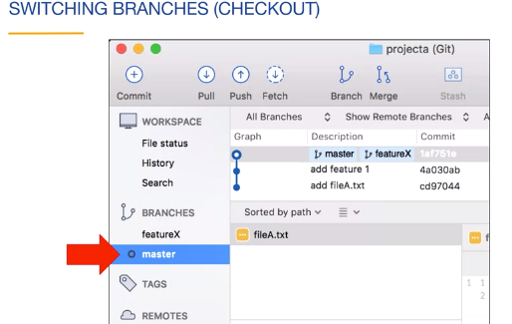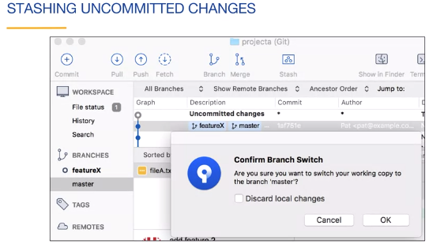

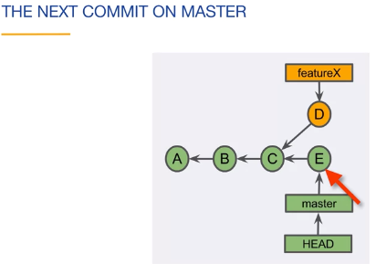

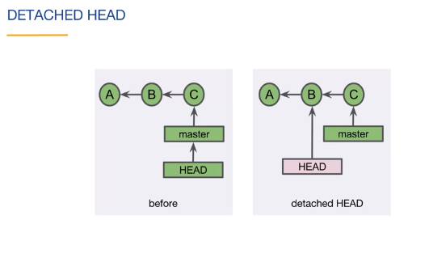

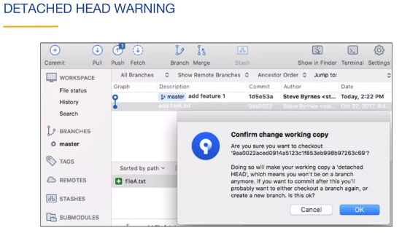

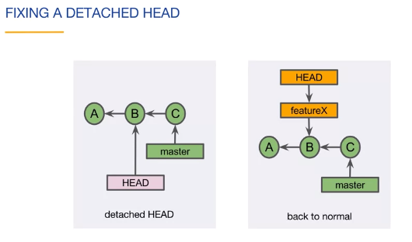

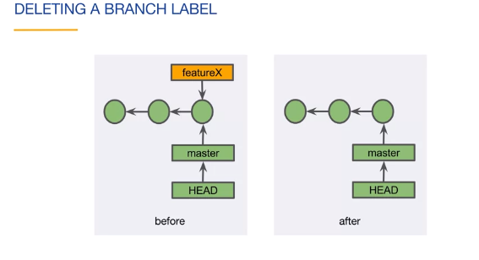

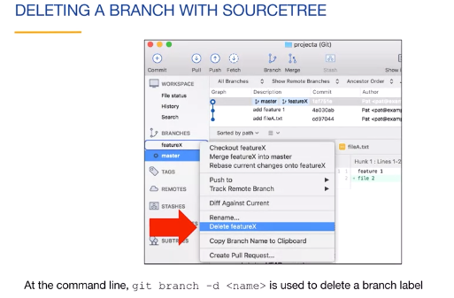

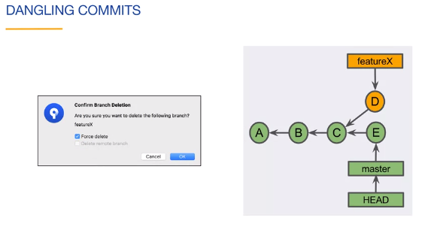

#### On Command Line: Branches

#### 

#### 

#### 

#### 

#### 

#### Here HEAD is still pointing to current commit master, not on new created branch feautreX.

#### 

#### So must checkout to labling HEAD on newly created Branch feautreX to update the working tree with commits’s files.

#### 

#### Checkout by command - git checkout branch_name

#### 

#### Firstly create branch by git branch branch_name then checkout by git checkout branch_name

#### 

#### We can combine both the above command by –b as git chekout –b featureX

#### It’s how changing HEAD label without disturbing the master branch.

#### 

#### 

#### After created detached HEAD we can not simply back on we need to create a branch label on that Node.

#### Which one of the following statements describes a detached HEAD?

#### The HEAD reference points directly to a commit.

#### 

#### 

#### -D instead of –d will cause to delete forcefully branch featureX when featureX branch is not merged.

#### Which one of these statements is true?

#### Dangling commits have an associated branch label. Wrong

#### Dangling commits will eventually be garbage collected. Correct

#### Dangling commits belong to at least one branch. Wrong

#### 

#### 

#### Docx for this chapter:

#### <https://d3c33hcgiwev3.cloudfront.net/_f446971cf5640543da624ba0b6ef7463_lab3_2_04b_cli_branches.pdf?Expires=1593388800&Signature=hn4FFFN1yDNhWU6pM5Aj6n~k7xMVVQp7xzxJx5SDh0liSzPwWNFuXhA815TEVmNJh9RnnzeYNN~QmEQu0U6~t1BvfPJzbwnirndWwQ3WMj60ZaCljoN71CdrAipKnDmMOPw3iM-I1F4DbcE1UNkOAGj7qKgW6GlYvQJ6Z1moBRo_&Key-Pair-Id=APKAJLTNE6QMUY6HBC5A>

**(Sourcetree) Merging**

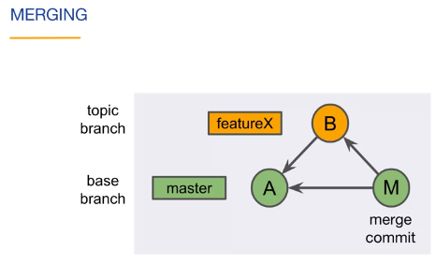

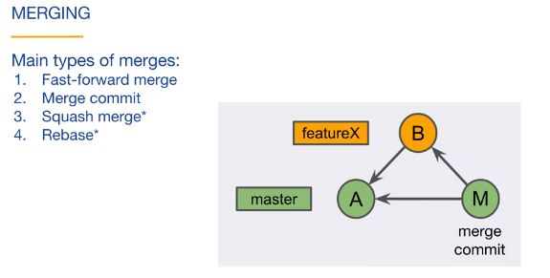

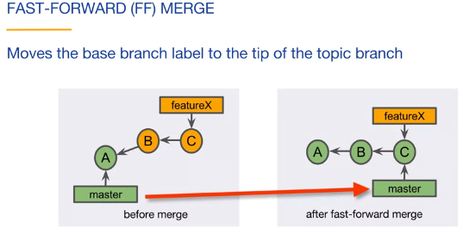

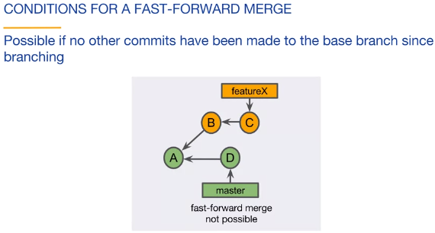

It is default merging by Git

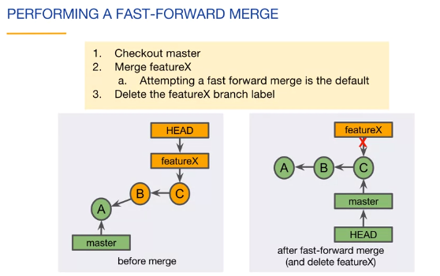

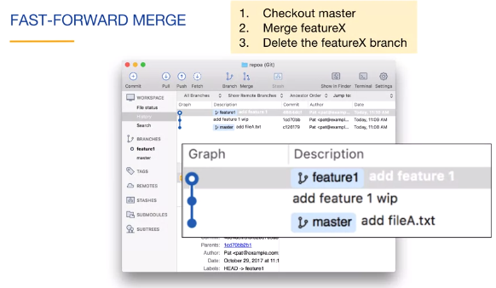

**Docx link:**

<https://d3c33hcgiwev3.cloudfront.net/_64b2b7144f1d35962c3ffc7b90ee599e_lab3_2_05a_sourcetree_merging.pdf?Expires=1593388800&Signature=RzmAPHZgEEvMpT9jLLXUXB4bmKNfJQrM0SMRJd-DXLLFRn5G-NPqNaKhJIAoGOZH3JVjf84wepPzpK-BiBSugt1tYZ2vwy9MiVFb7Z--bm3FS-Txsoyqp4qFMcrqF8XBiRPaa5T9UCiW1do9MOuq-ACZxp1uwXfE~9CmD~utVZA_&Key-Pair-Id=APKAJLTNE6QMUY6HBC5A>

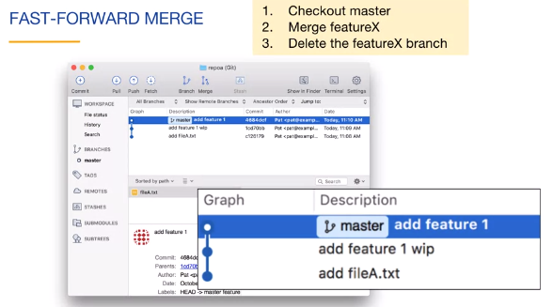

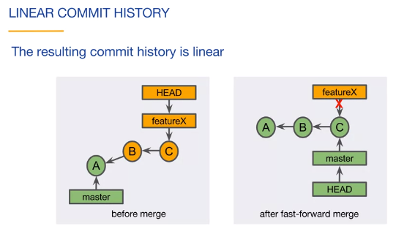

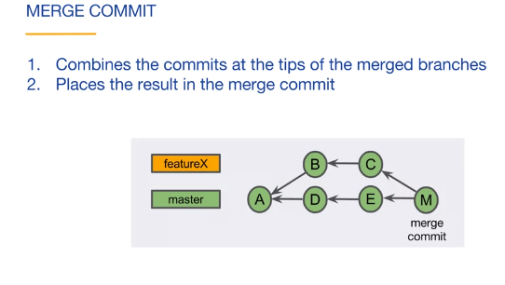

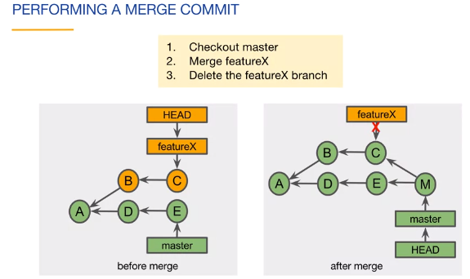

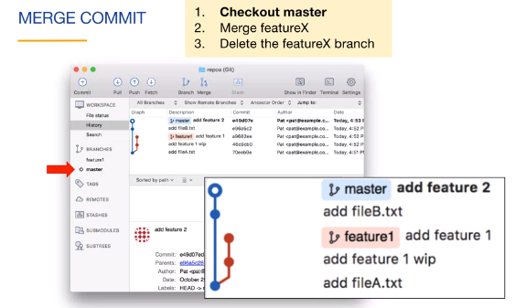

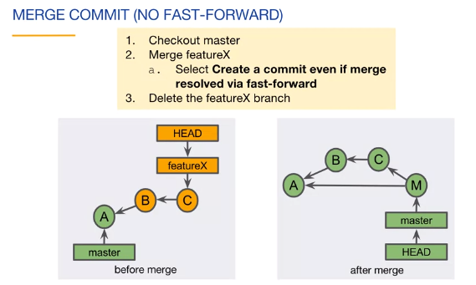

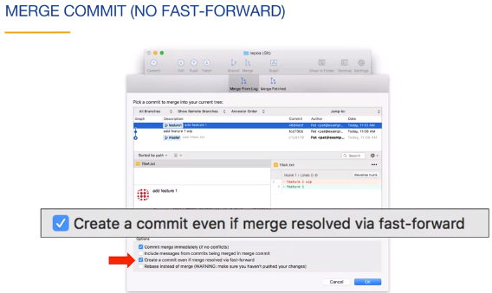

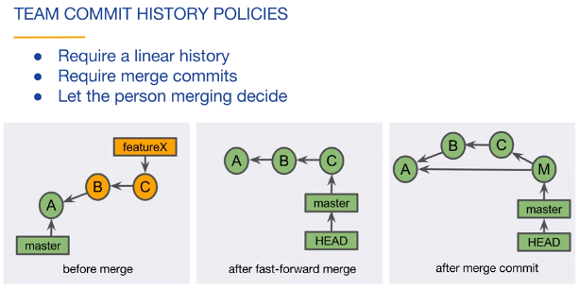

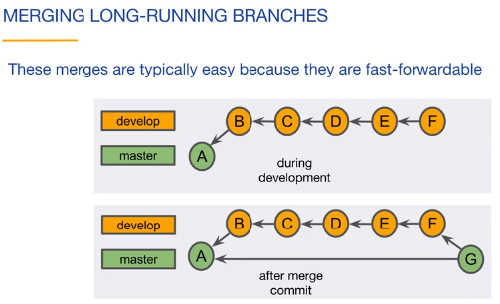

**(Command Line) Merging**









It is default merging by Git



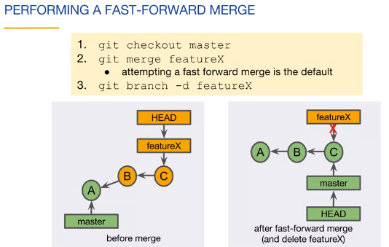

So if no other commit attach with base branch and added the features of featureX branch then it can be merged by checkout the master branch then merge of featureX branch with master then it is need to delete the featureX branch to make commit graph linear.However it is not must to delete the featureX branch.

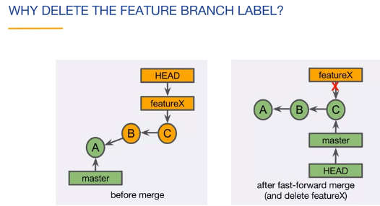

Very Important

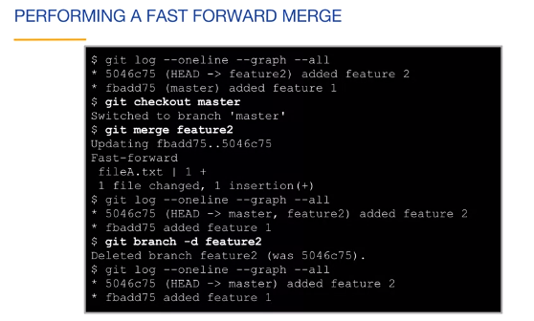

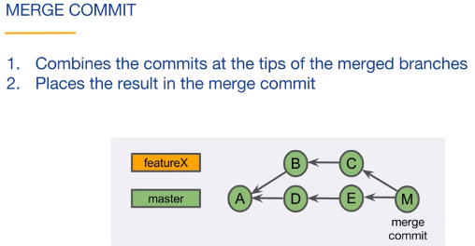

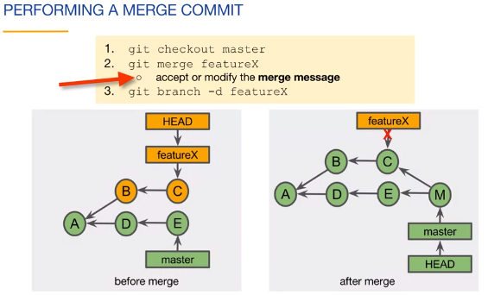

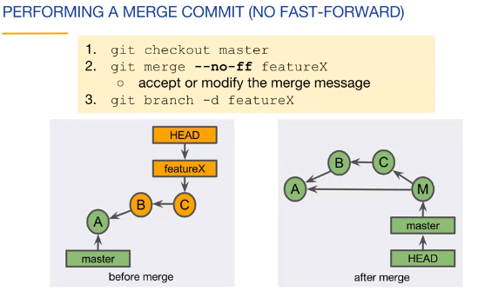

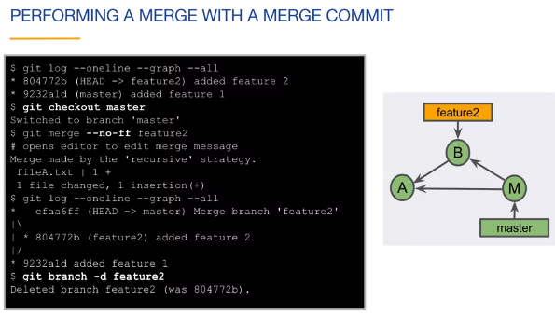

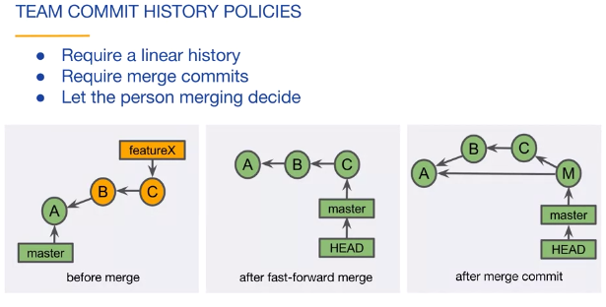

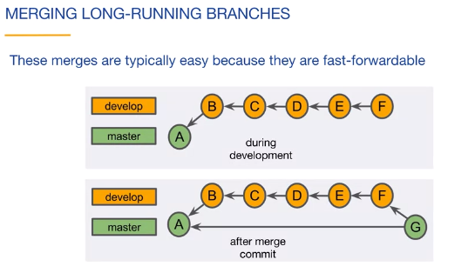

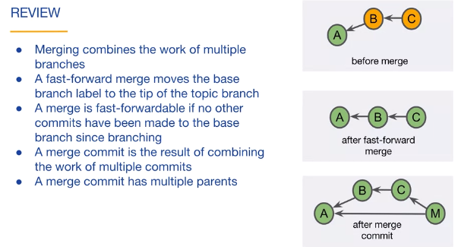

Docx link for this chapter:

<https://d3c33hcgiwev3.cloudfront.net/_64b2b7144f1d35962c3ffc7b90ee599e_lab3_2_05b_cli_merging.pdf?Expires=1593388800&Signature=SZSX4auOz2Fz-7bUetYgWtFe2SAZvBKhxNbo6VrYmcgZq9aJuFN0~P6Sph9YtVSnV7sylWg965KV-frmYmCd~5l4J4PpZEoEFcyKBBcu5TRiSYHpue8LaAJlDwPR5m2RUwbGpzDOWYespFbB0Bt1tF0dhyAWBOqz-fa7eUbdNjI_&Key-Pair-Id=APKAJLTNE6QMUY6HBC5A>

**(Sourcetree) Resolving Merge Conflicts**

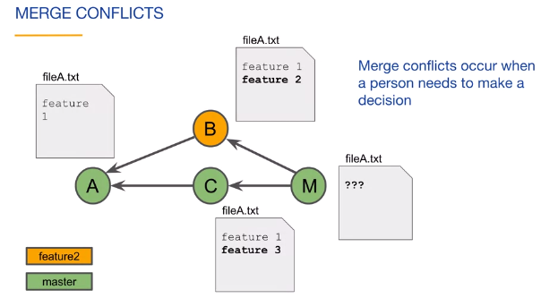

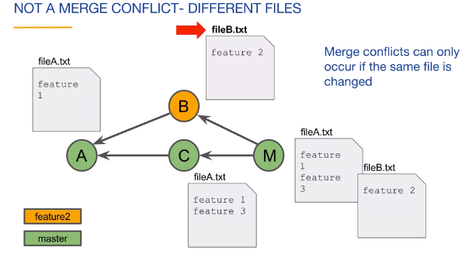

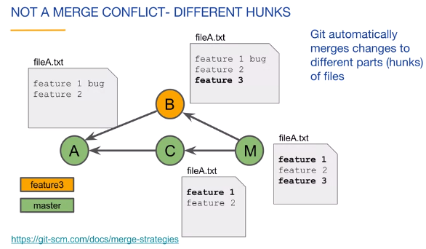

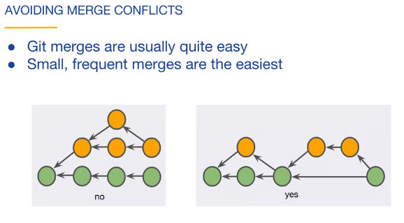

* A merge conflict occurs when two branches change the same hunk in different ways.

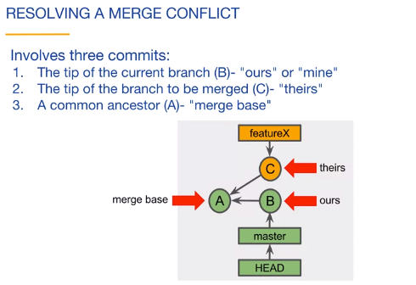

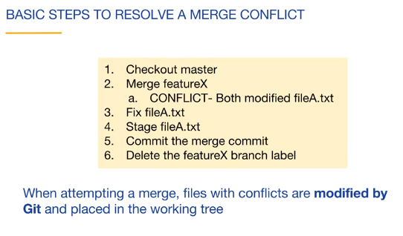

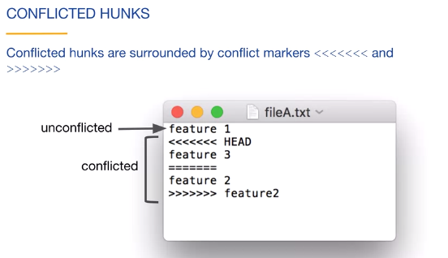

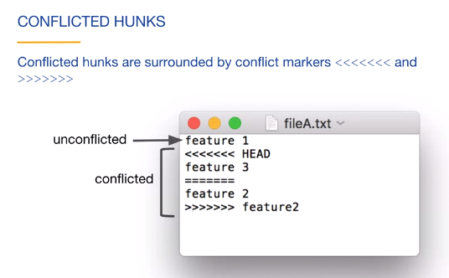

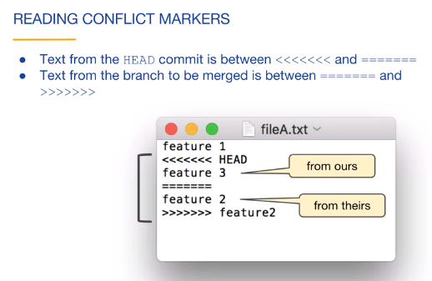

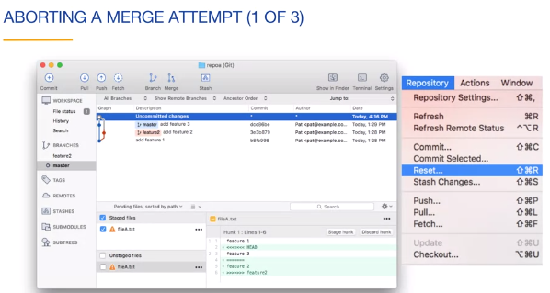

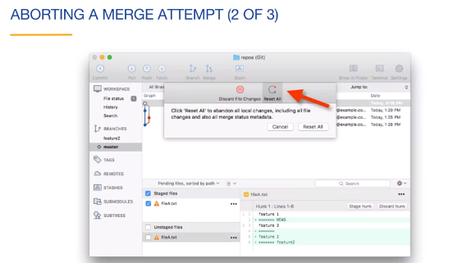

**Docx link for this chapter:**

<https://d3c33hcgiwev3.cloudfront.net/_1e8828946758d03f80f1f9fcf04ba860_lab3_3_01a_sourcetree_resolving.pdf?Expires=1593475200&Signature=XftxBZ1e3htUiztOsdZM-nJEOJftOW1p8ixolsURWEn4Y1JIIDBeR~oszi7xcH0zF2KSVgDH~zUPRgrDS08CVUKQoqFaEBV5OF~R7~ZyeGVo1e0dSNEr0AoJW-ig5eA8usnkp~PfXhxBmv6oxubI8MAaHppIfQJxE01KDBQ4b0E_&Key-Pair-Id=APKAJLTNE6QMUY6HBC5A>

#### (Command Line) Resolving Merge Conflicts









* A merge conflict occurs when two branches change the same hunk in different ways.



#### 

If there is change in same file by different branch then will be leads merge conflicts.

So we need to resolve the conflict to merge successfully.

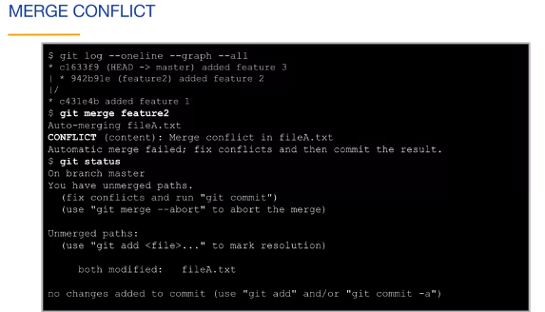

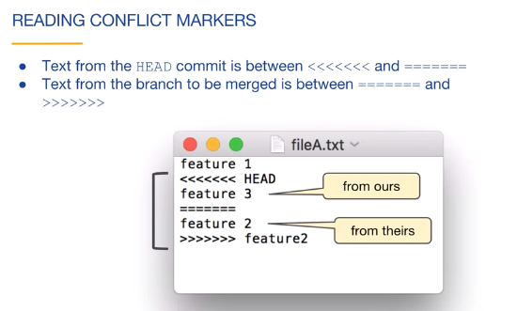

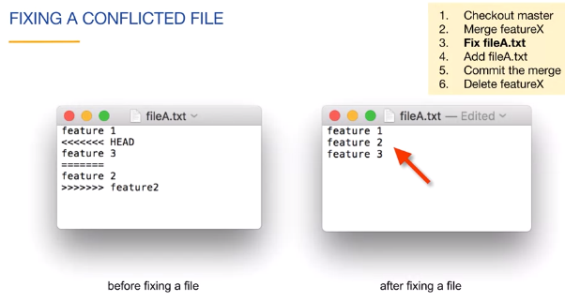

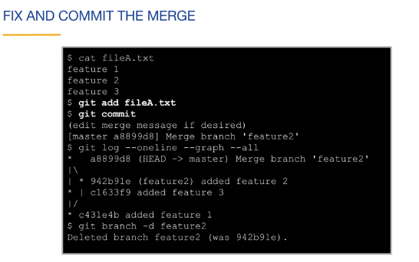

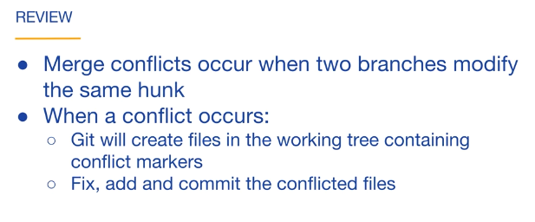

Docx link for this chapter:

<https://d3c33hcgiwev3.cloudfront.net/_87cb34cb37eed59543f661d5a8f8ea12_lab3_3_01b_cli_resolving.pdf?Expires=1593475200&Signature=Ebpj9yX1WEvbyaTeFAam~jI6AARepb~kZhYJjJoP5FR34W3FKgm8OKSQmJ0Ygl6xb8WKvrtTZe9XR8Ik~4duLjOVjVO-0VzDh3YYhJuZgfkCNavge03QebLo85Bvw2~2xEwZD9Vx9IsICC9-k~ipZSiF1jBbP-zHC4RgGdREi2Y_&Key-Pair-Id=APKAJLTNE6QMUY6HBC5A>

#### (Sourcetree) Tracking Branches

A tracking branch is named <remote>/<branch>.

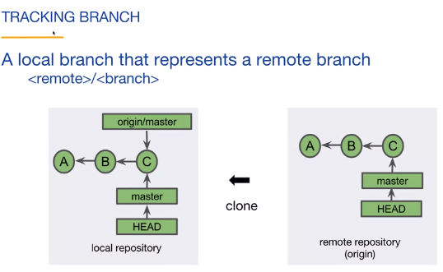

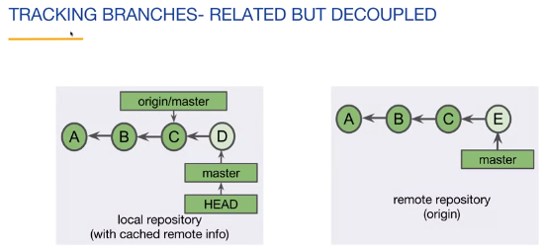

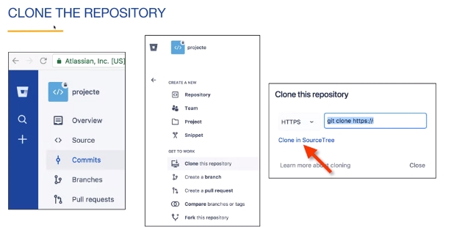

**From Bitbucket git web hosted site**

* When you clone a repository, the default branch is set up as a tracking branch.

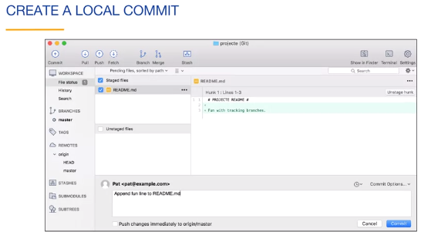

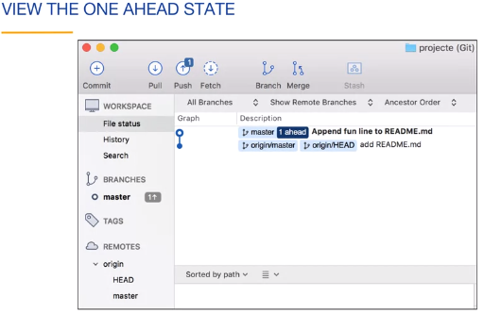

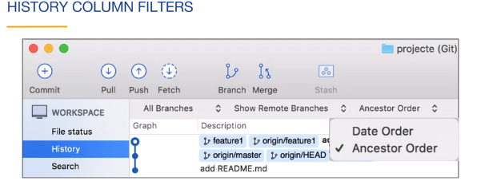

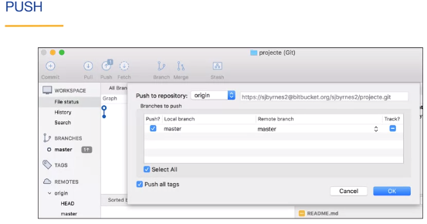

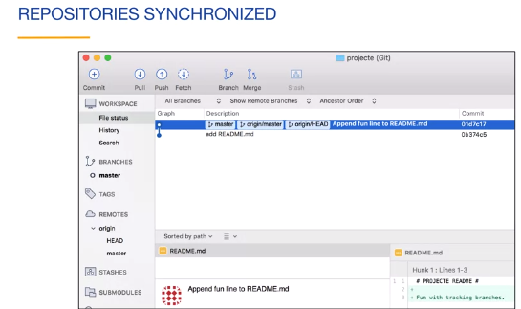

**Docx link for this chapter:**

<https://d3c33hcgiwev3.cloudfront.net/_101790935921a25e6b82d0a658085260_lab3_3_02a_sourcetree_tracking.pdf?Expires=1593475200&Signature=cjRDnNjEkXLIqoXqvfq0HEvPqAIwkv3SLeq3FnB2dew8eBJa5WVBUXYaeEB9X-xc5~qU5DmJpNlz-sry2mtuOF8WNuTPDhex~8DHLmL8UTRyjQZcAV1avZvWrHuWVU-wsn9xMlvNXR~geqlF7SIk0QqQSh2pMkR10dW0tp9Y7Ww_&Key-Pair-Id=APKAJLTNE6QMUY6HBC5A>

**(Command Line) Tracking Branches**

A tracking branch is named <remote>/<branch>.







**From Bitbucket git web hosted site**

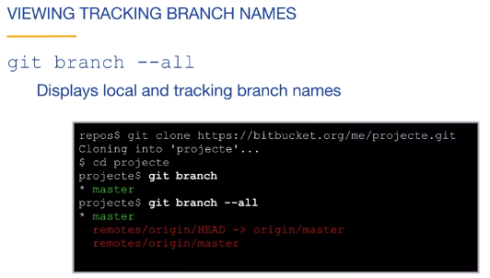

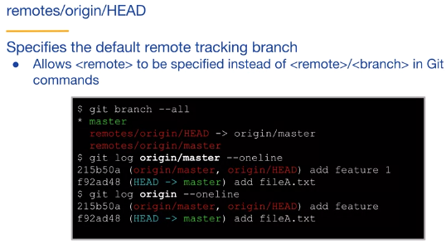

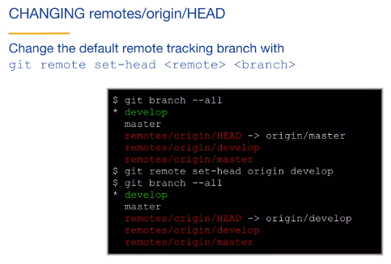

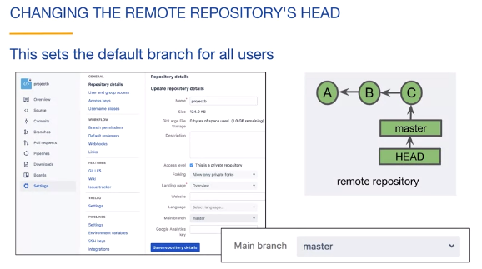

We can change the remote repo’s HEAD by on Git web hosted site as fallowing:

Setting 🡪 Main branch 🡪 change

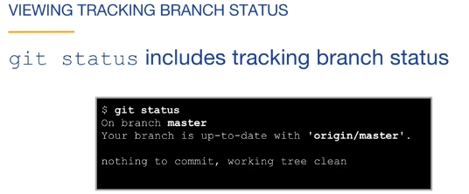

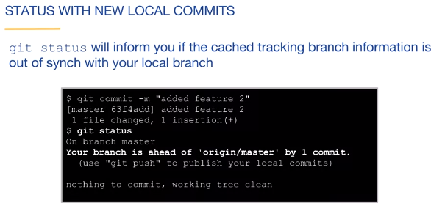

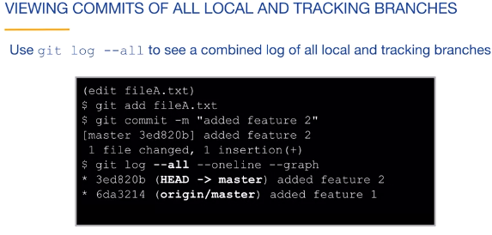

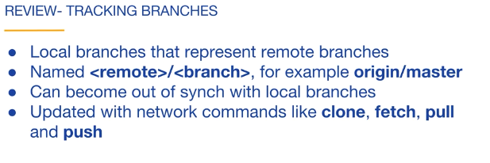

Docx link for this chapter:

<https://d3c33hcgiwev3.cloudfront.net/_101790935921a25e6b82d0a658085260_lab3_3_02a_sourcetree_tracking.pdf?Expires=1593475200&Signature=cjRDnNjEkXLIqoXqvfq0HEvPqAIwkv3SLeq3FnB2dew8eBJa5WVBUXYaeEB9X-xc5~qU5DmJpNlz-sry2mtuOF8WNuTPDhex~8DHLmL8UTRyjQZcAV1avZvWrHuWVU-wsn9xMlvNXR~geqlF7SIk0QqQSh2pMkR10dW0tp9Y7Ww_&Key-Pair-Id=APKAJLTNE6QMUY6HBC5A>

**(Sourcetree) Fetch, Pull and Push**

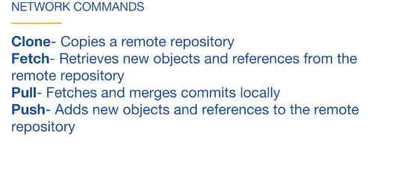

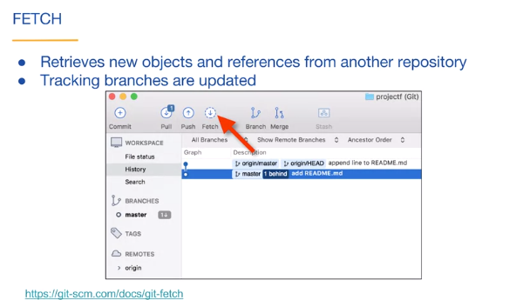

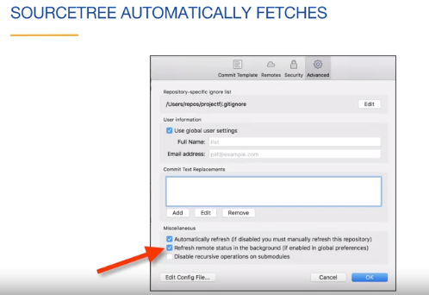

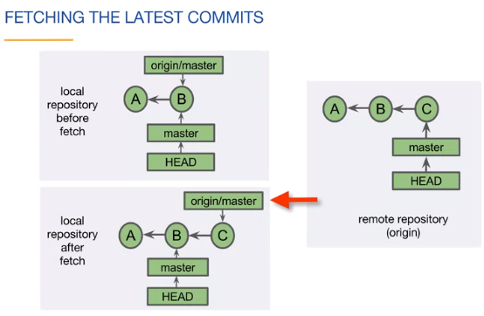

* A fetch may update your tracking branch.

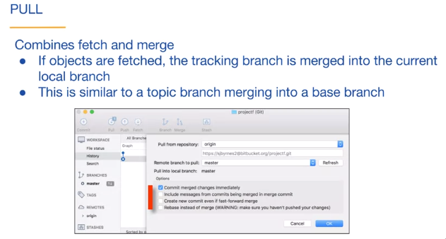

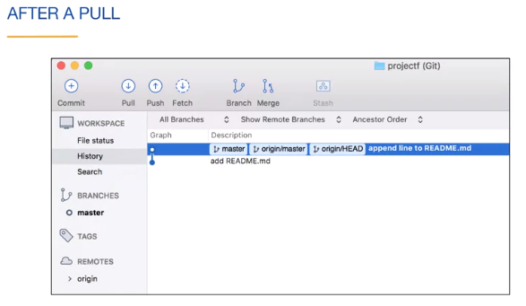

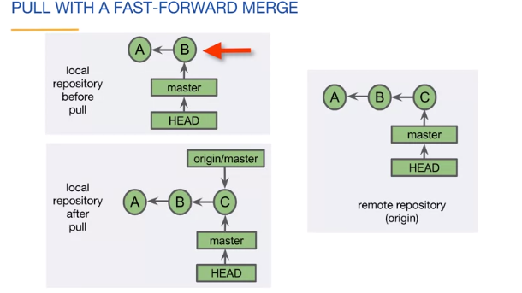

After Pull operation both local and remote repo is synchronised.

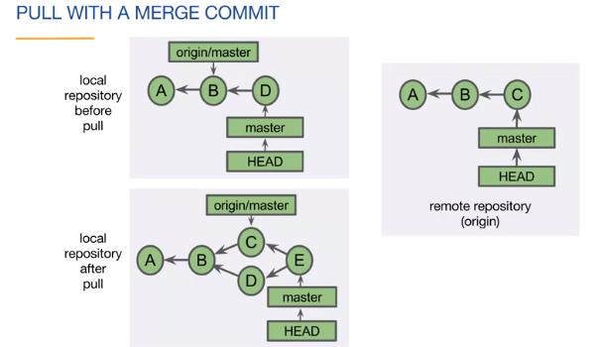

Docx link for this chapter

<https://d3c33hcgiwev3.cloudfront.net/_da45864117746f71aeeffeb6fcdc98e5_lab3_3_03a_sourcetree_fetch.pdf?Expires=1593561600&Signature=ESL-XZSIAyCFynESIJk1HV0I~xI14aWtIQphEiwJ~2IbbvVPFYx9jyRfFKpFZfF8EzL8SNLY0w4j-lH33gLQNqciDOw7Y6DKxgIC9DFm8pwVzMiqNjU6Sz0jpbHVgwwN3zLK5UJe3HzSdpkbh10g~gXuC4693t7gQlpeWjjTHIs_&Key-Pair-Id=APKAJLTNE6QMUY6HBC5A>

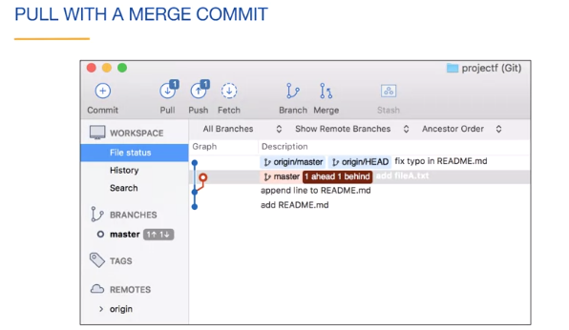

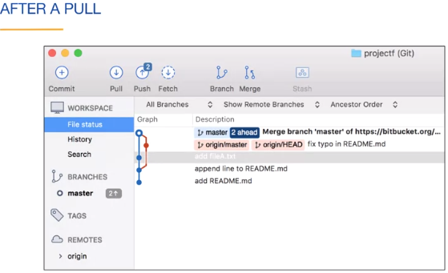

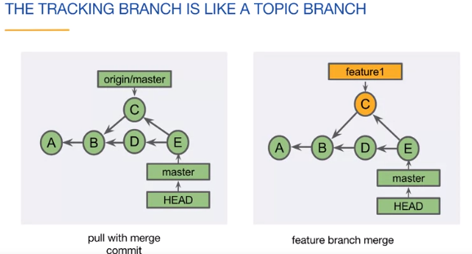

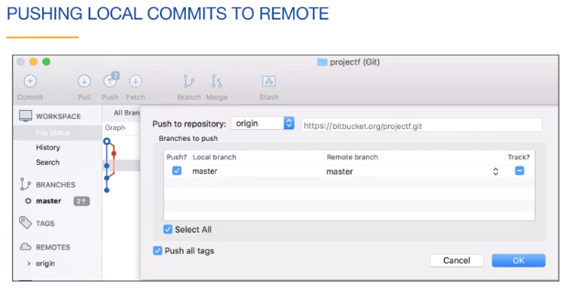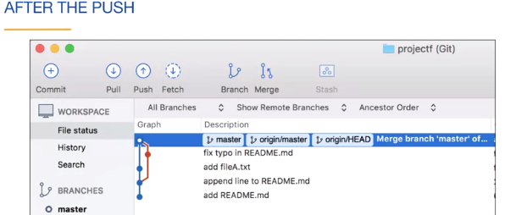

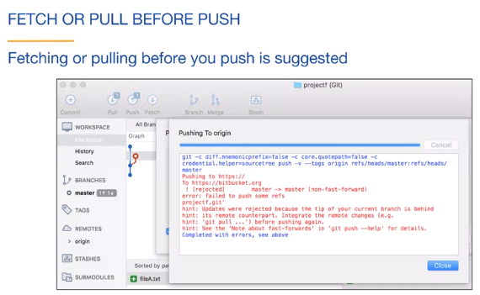

**(Command Line) Fetch, Pull and Push**



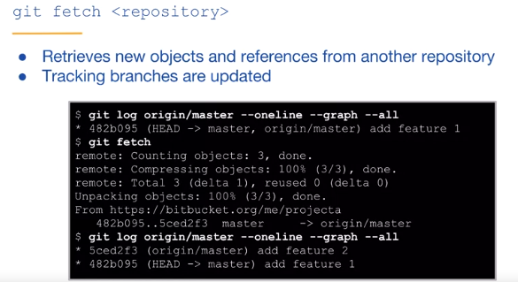



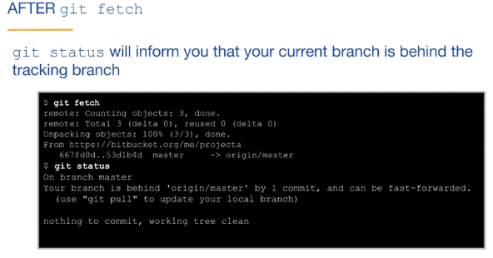

* A fetch may update your tracking branch.

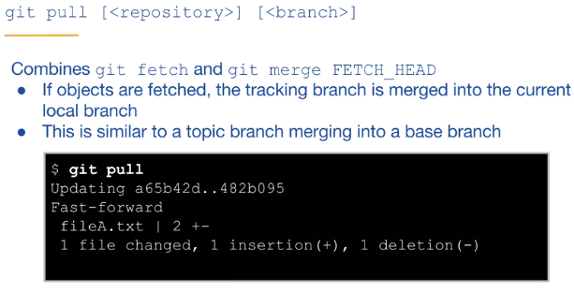

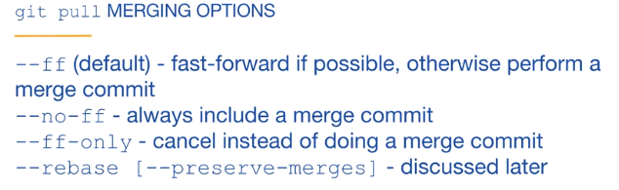





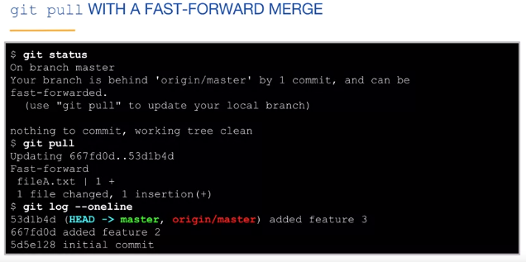

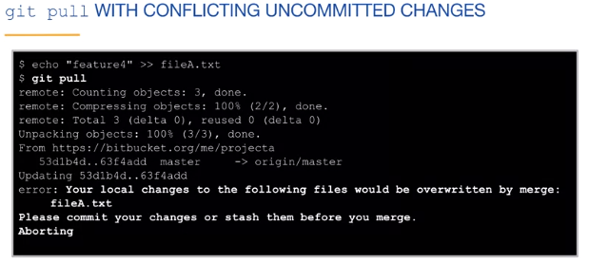

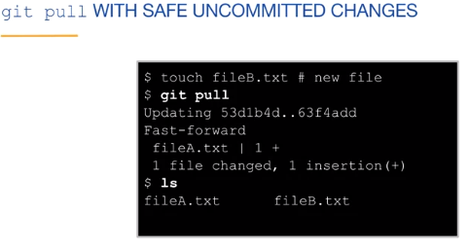



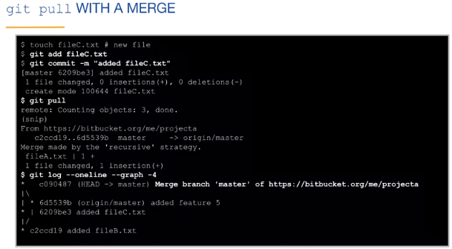

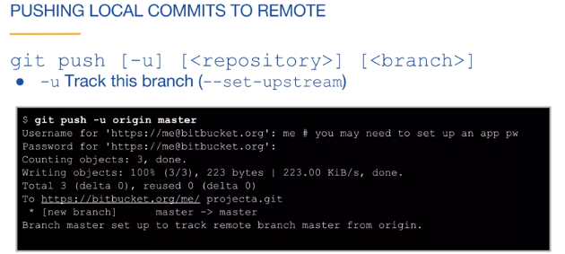

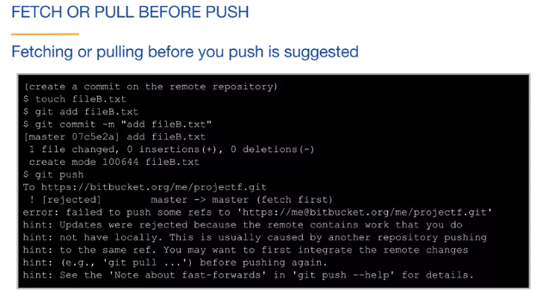

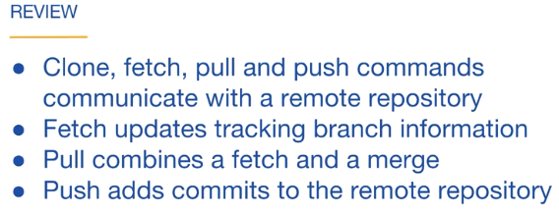

Docx link for this Chapter:

<https://d3c33hcgiwev3.cloudfront.net/_c937644717897bbd7c26663e91dabb55_lab3_3_03b_cli_fetch.pdf?Expires=1593561600&Signature=NIv~raIj3Cg9sALqE8U~HBEV4y2rpsWYFXlqd~2uuuwN9tSHASEXm0WtAegwpKp4qZNztMc3Cjma2AR8Ww5OK2fQ2LxK84xTKIEUIyc6yAMKl~Rbac6ZZYRj73R1hfgnBK2dcdCig11DhlQA2M~bYV3gSKrWgl5f3AJ7NQgx~zs_&Key-Pair-Id=APKAJLTNE6QMUY6HBC5A>

**(Sourcetree) Rebasing**

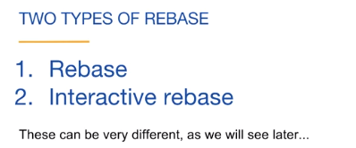

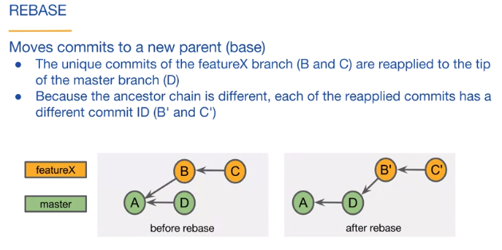

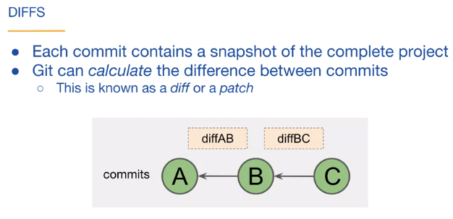

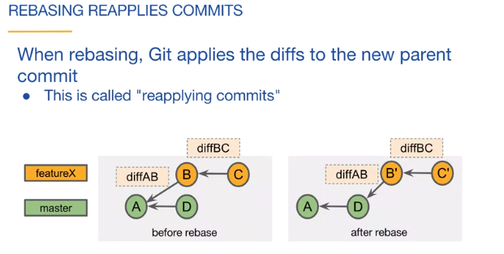

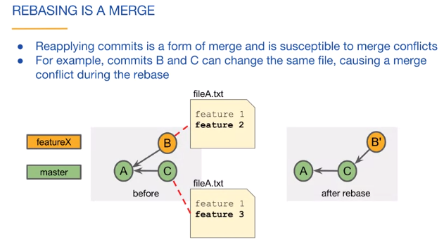

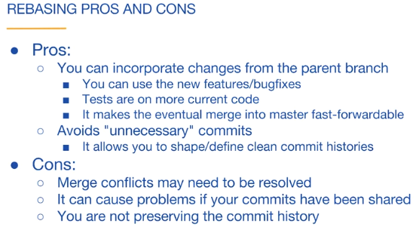

* Rebasing is a form of merge.
* 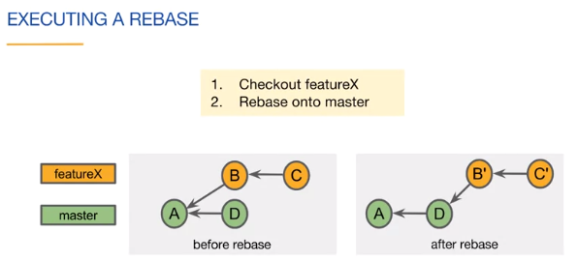

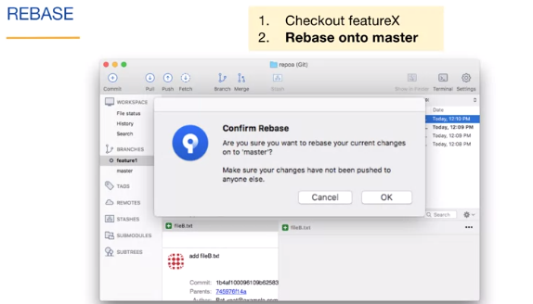

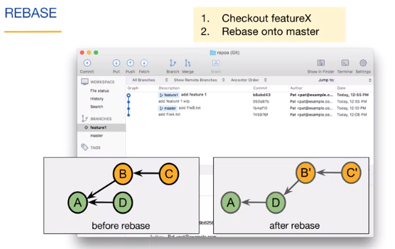

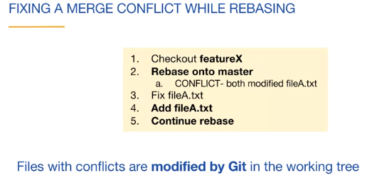

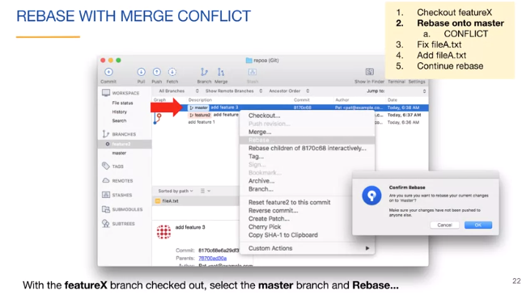

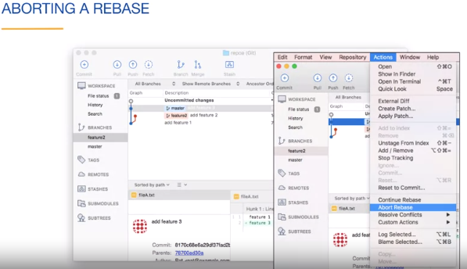

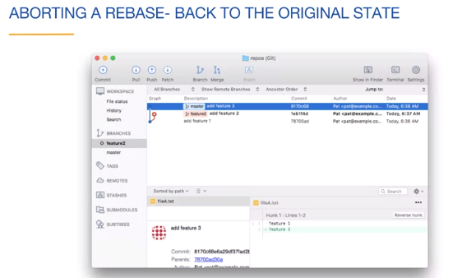

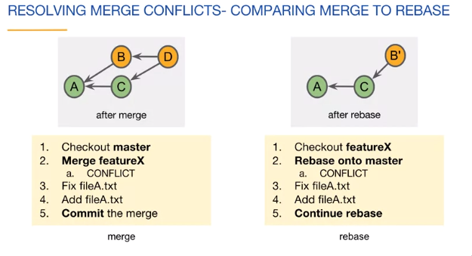

Docx link for this Chapter:

<https://d3c33hcgiwev3.cloudfront.net/_1d2b44bf87282bacb3a9686ab5d7e074_lab3_3_04a_sourcetree_rebasing.pdf?Expires=1593561600&Signature=EWQXYE6Qst4xTLQWv1zHTbWFSXYecmpiZFwVAFkE9Vh1v~26g5ILjKEMDK0E7zjzSs3sMgrjzRLqa5F1bzL0AtfZzGiYvRgYQxNmUc3mUDuDhzSkFEoD6LsdX8FO576tJxamJNTaO4QhiCMZ-Hv1TYWSn3C5MrILVq~k6w1a4Pw_&Key-Pair-Id=APKAJLTNE6QMUY6HBC5A>

**(Command Line) Rebasing**

* Rebasing is a form of merge.













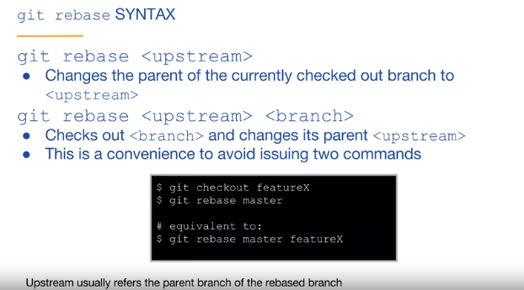

Checkout the feature branch. Rebase onto the base branch.



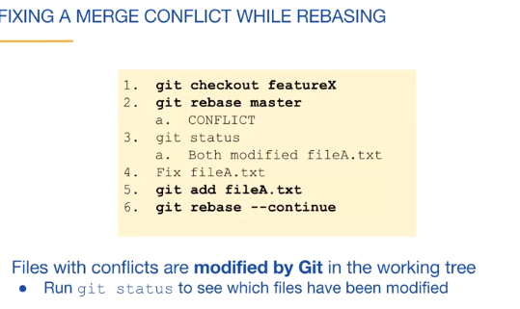

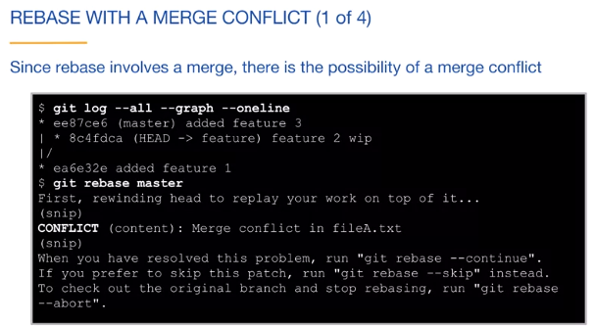

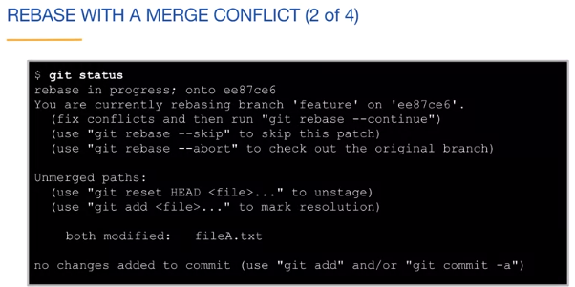

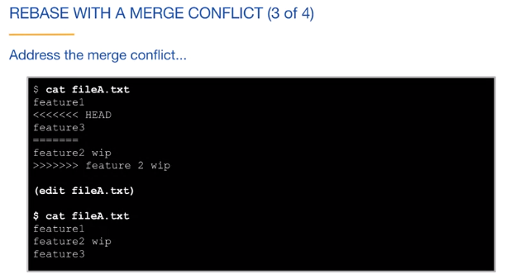

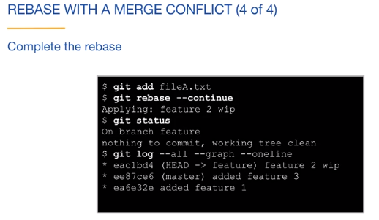

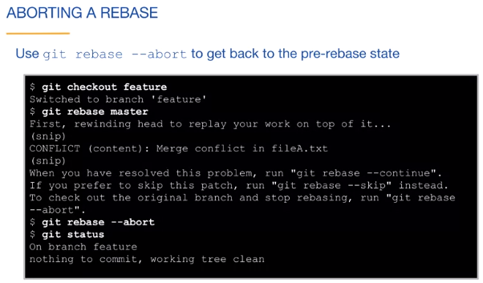

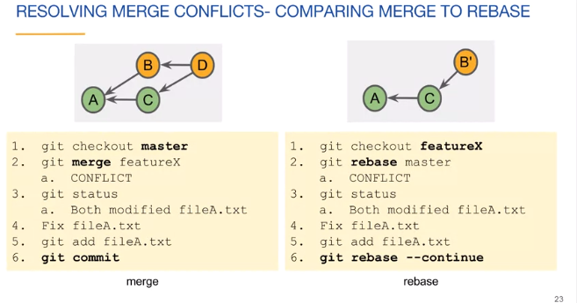

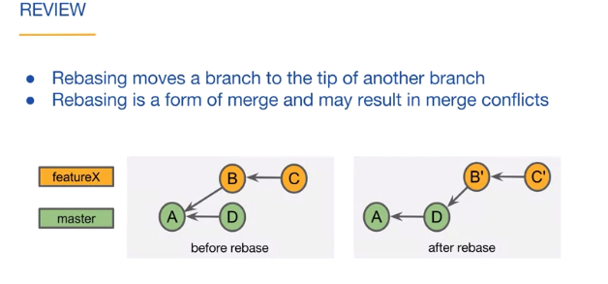

Docx links for this Chapter:

<https://d3c33hcgiwev3.cloudfront.net/_b6770133b65ea1a75a1917483782fd4f_lab3_3_04b_cli_rebasing.pdf?Expires=1593561600&Signature=dh9fhaTGxqEKApxgMhq~GV8AYM1lb3QISiDQezCupWaSx0demfwBR7Oqo~HFNmGVL-UY8DvbgsjqkmybOAMao0YFi~xsJ3Ot1qLJ9HJirjsRS~Lm2zR4q9wf8uPrHTmhy3r10lO731K-qT0eVAHRuJxdNjYwfj78pJ6ShCijHCw_&Key-Pair-Id=APKAJLTNE6QMUY6HBC5A>

**(Sourcetree) Rewriting History**

Amending a commit always changes its SHA-1.

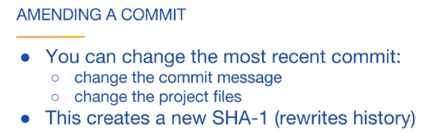

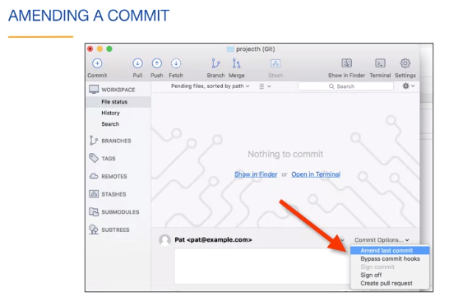

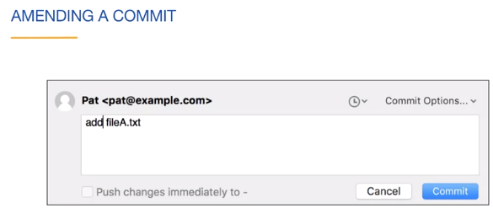

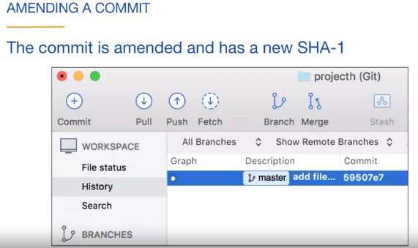

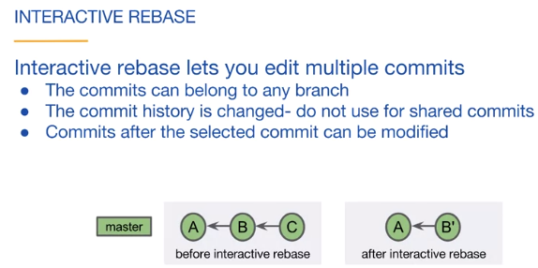

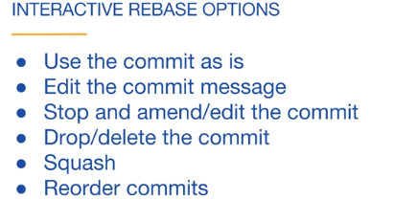

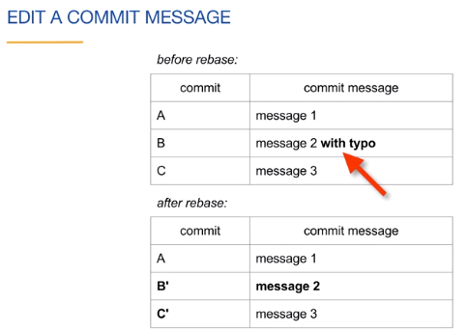

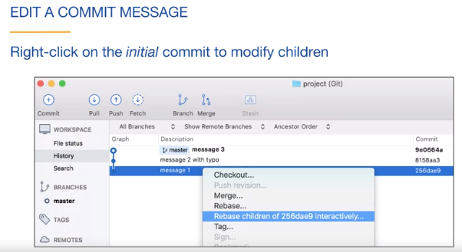

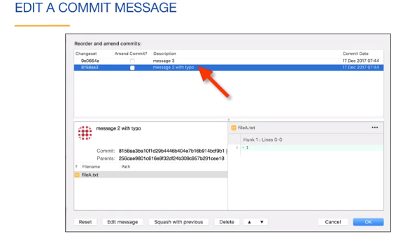

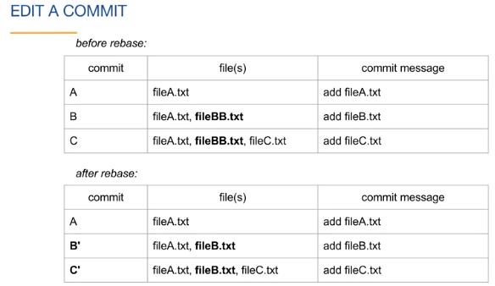

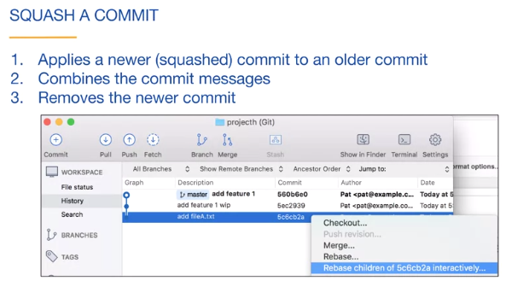

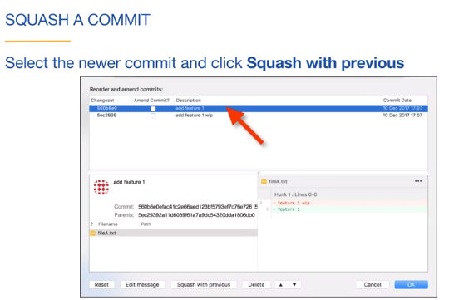

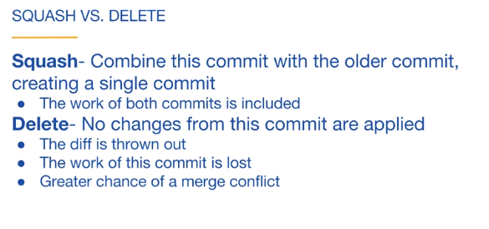

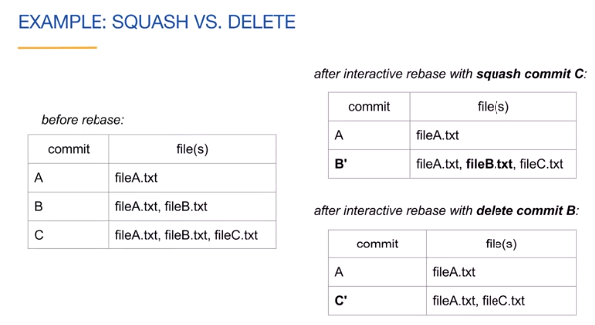

Which one of these statements about interactive rebase is true?

The children of the specified/selected commit can be modified.

Docx link for this chapter:

<https://d3c33hcgiwev3.cloudfront.net/_0a31619749a9b615a9f72604a90926e2_lab3_3_05a_sourcetree_rewriting.pdf?Expires=1593648000&Signature=CGkvJ~YpDpTZjFMr4Jir7P3DBQnHzdXf~PbVWkrSChYjIks5nObwTP0MVoWj4blZ62YRA0JwtM51aSIfzvGMJRzn~dFh54AAJsLJivWVK8~V8Iji8UqXzIRVqBx9zdrIbT1cEXVRHdOjUD362KO-1IEWDCrCZCsUDSPDIlK8P~4_&Key-Pair-Id=APKAJLTNE6QMUY6HBC5A>

**(Command Line) Rewriting History**

Amending a commit always changes its SHA-1.



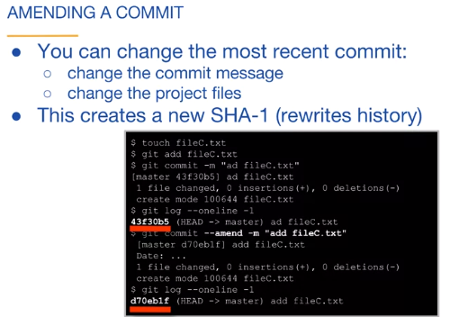

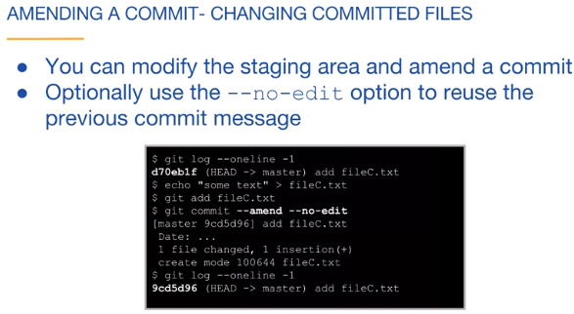



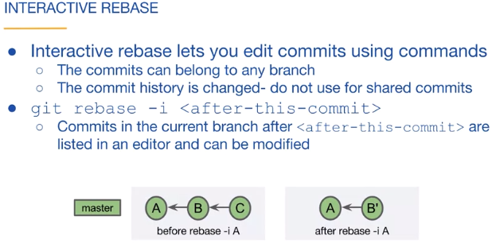

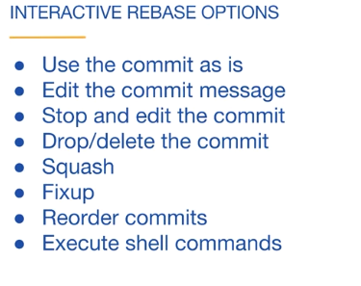

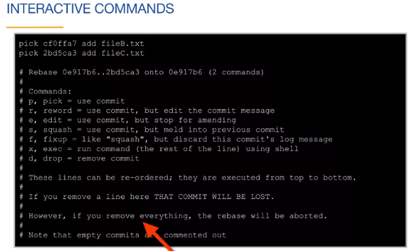





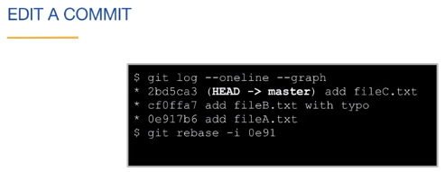

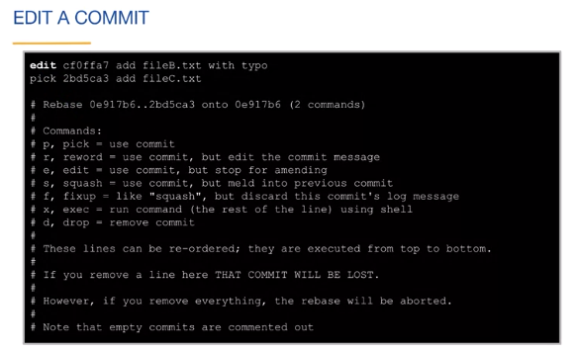

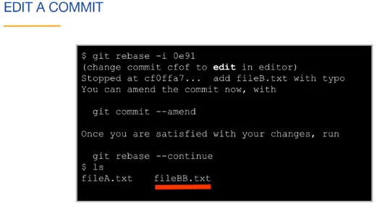

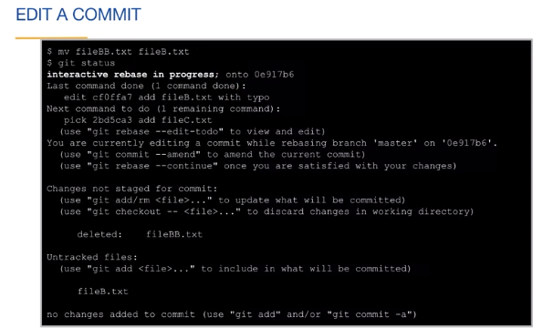

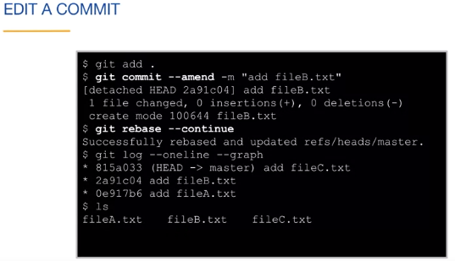

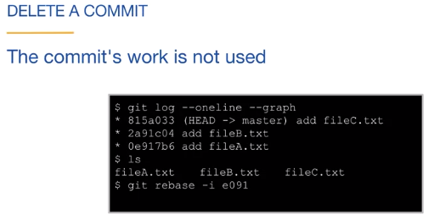

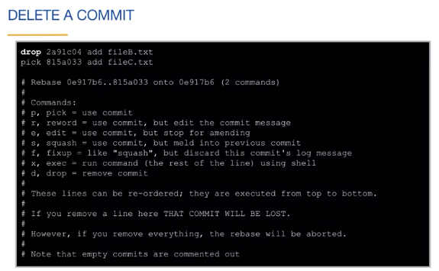

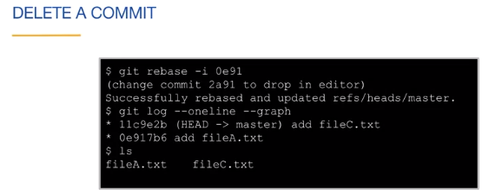

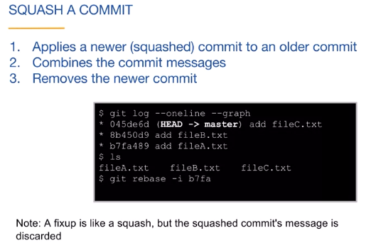

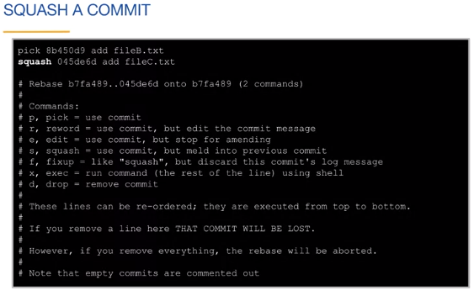

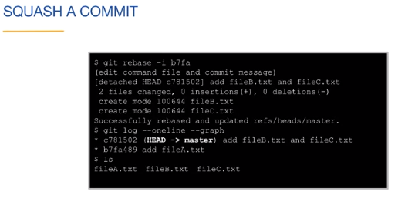





Which one of these statements about interactive rebase is true?

The children of the specified/selected commit can be modified.

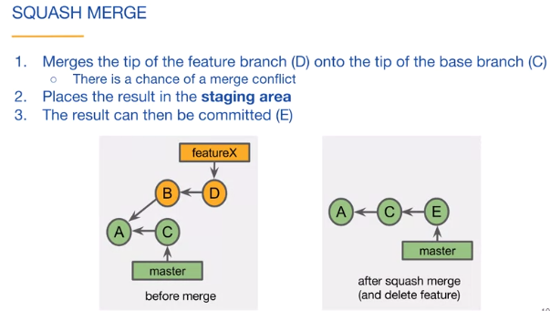

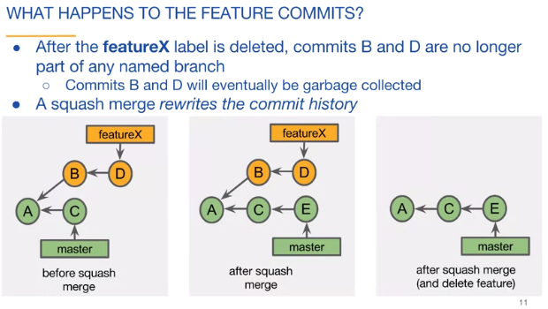

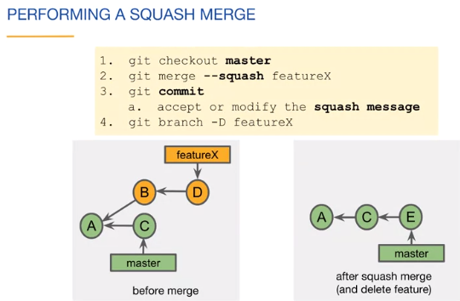

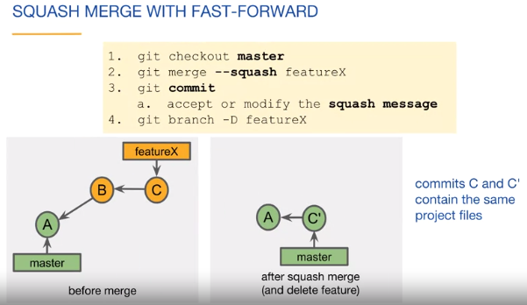

What is the result of a "git merge --squash featureX" command?



Modified file(s) in the working tree.



A single linear commit.



File(s) added to the staging area.

**Correct**

Correct. "git commit" still needs to be executed to create the merge commit.

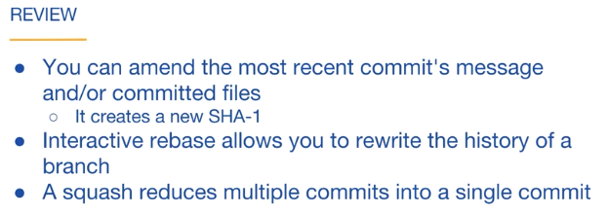

Docx link for this Chapter:

<https://d3c33hcgiwev3.cloudfront.net/3dCs1RKYEem6Pgo4-YwqLg_de19ea00129811e9ab7e1d48236c2927_lab3_3_05b_cli_rewriting.pdf?Expires=1593648000&Signature=XhEAetZaBQg9u2QH0GrBdTK906ugmQbnKukWH0TRlBgptCLWKqPPPHHy9x87Jr1-IROE-ZtVjgPL~zN195peGT9XjOYTTB~OP7u-P7kjIoXRA-owBO0-JAn4bBumPbRooitvDoLELjBvQZnIgF~72~zAdpUOKqrS5a-olEpjb-k_&Key-Pair-Id=APKAJLTNE6QMUY6HBC5A>

**(Sourcetree) Pull Requests I**

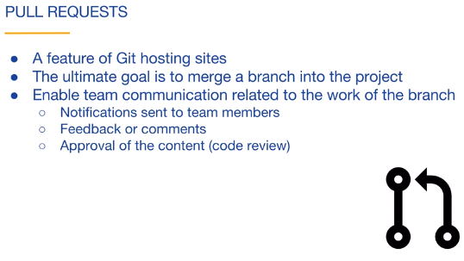

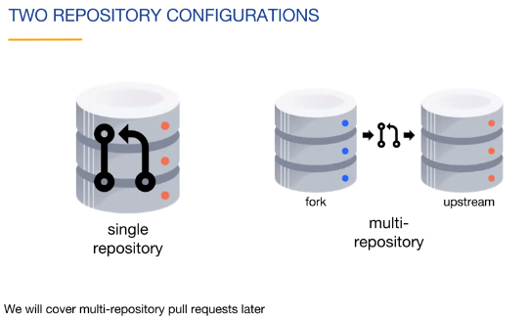

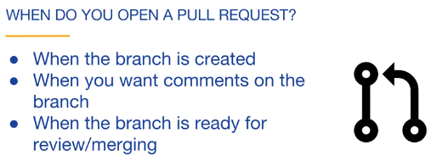

Docx link for this chapter :

<https://d3c33hcgiwev3.cloudfront.net/NlbbfB1VQf2W23wdVeH9xA_cfe7fc66c4ff4721b006fb944b290886_lab3_4_01a_sourcetree_pull_I.pdf?Expires=1593734400&Signature=S4vRSwVLpMrlPknND~0n2t6ANL90G-5ulyQZ1lpwPs8SyViejMGo9wfcQA0vAsErEh6vxSBpgsNlNWORoxz67anCIP1qWIpVUdR8vVINxeLyVg98pEVmzOoMvO9yLtlpi2Dssx1GiGvOgPtClVgHRYGcsUl8ep62Io5UOgw~yqQ_&Key-Pair-Id=APKAJLTNE6QMUY6HBC5A>

Not end

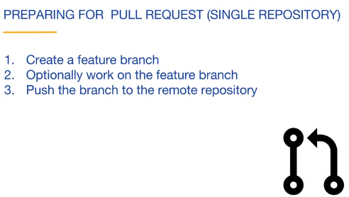

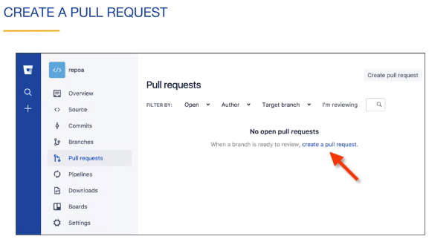

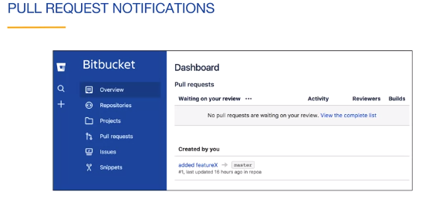

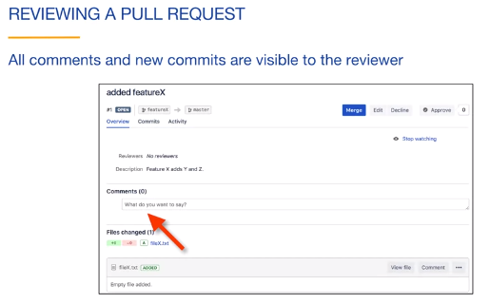

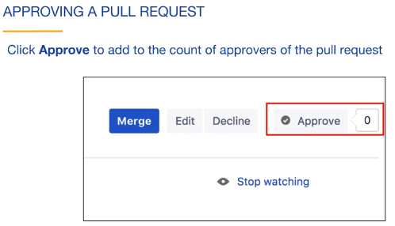

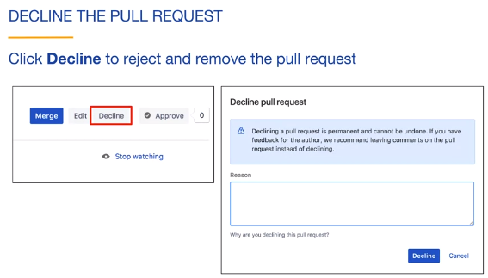

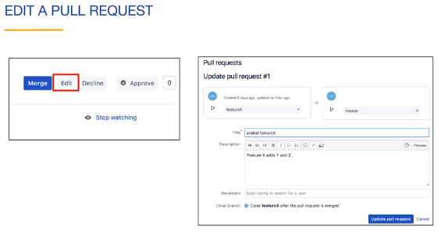

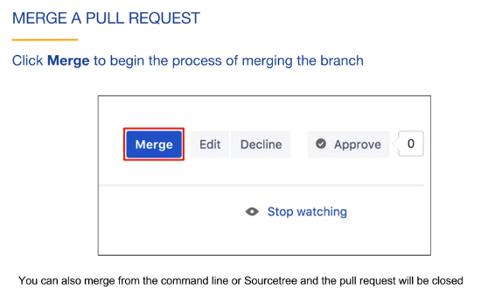

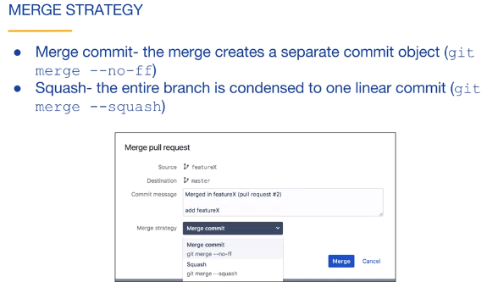

**(Command Line) Pull Requests I**









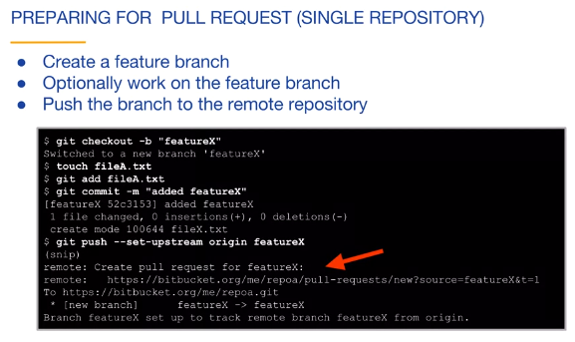



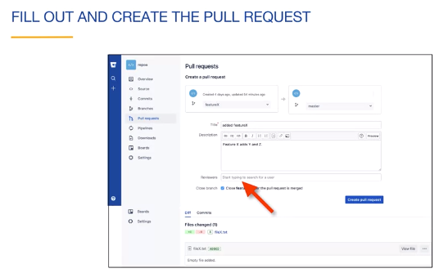















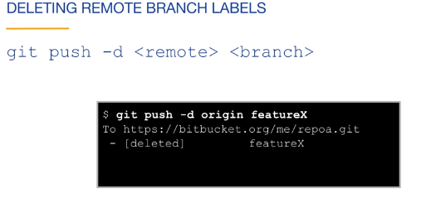

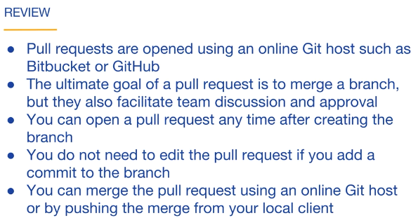

Docx link for this chapter:

<https://d3c33hcgiwev3.cloudfront.net/l7l67uVPRIi5eu7lT_SIBQ_d83aeec316de4134826aa8aa55813a4b_lab3_4_01b_cli_pull_I.pdf?Expires=1593734400&Signature=ESN~oUTFSalhRotUGAJFiarVntqsLfyivPwpB4qM01FoqsN4kNY3fjVKpKPYLv9URVHPCGFTJPy16afVHKHleawN9icrX3KQa8eAgZ734z48x-CmU8kXYnONGvDLXTl0jou3jSV8TNJG2AL8DzOwfihEeAC28v9MQ4nF4CzHPNQ_&Key-Pair-Id=APKAJLTNE6QMUY6HBC5A>

**Pull Requests II**

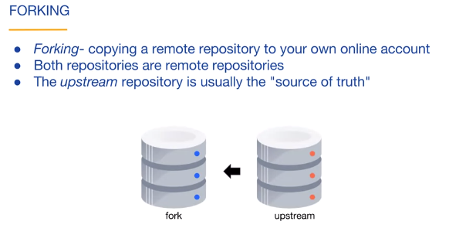

 The upstream repository is the project's source of truth.

And A fork is a remote repository.

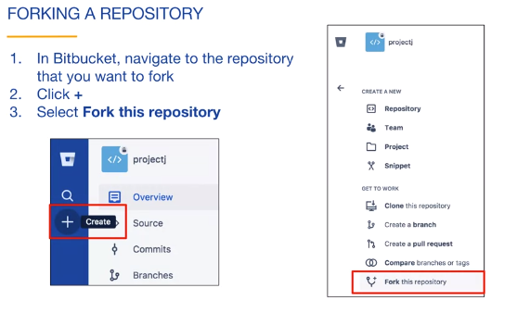

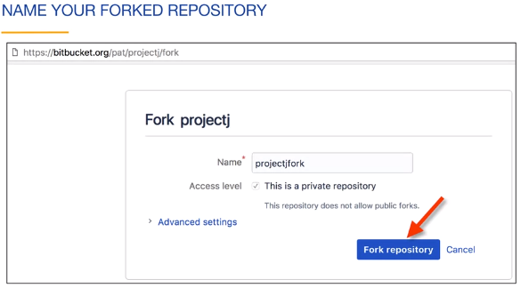

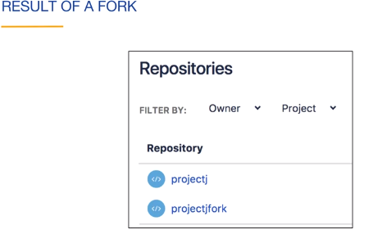

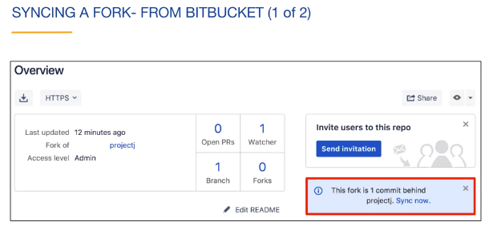

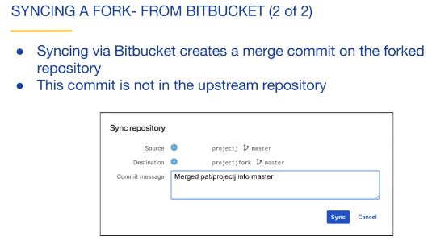

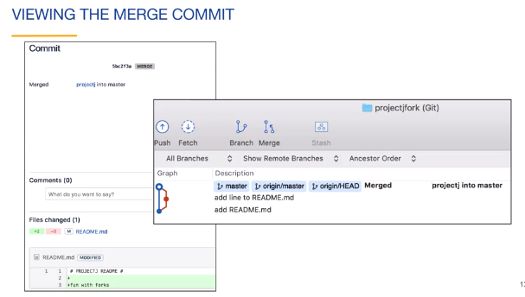

* After synchronizing a fork, what should you do to update a local repository related to the fork?

Fetch or pull changes from the fork.

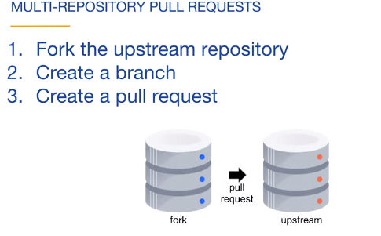

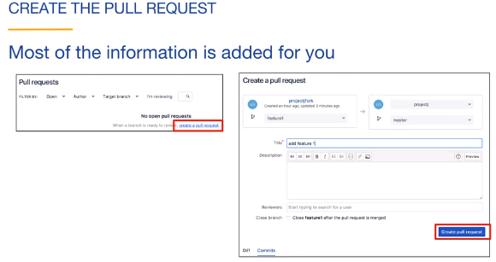

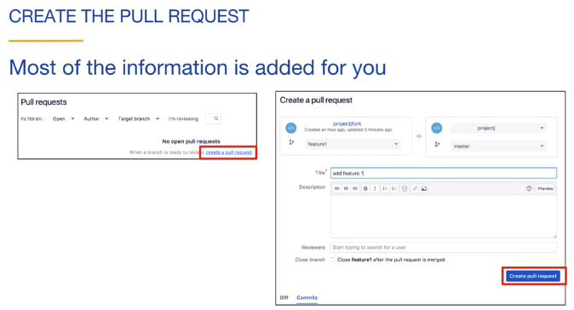

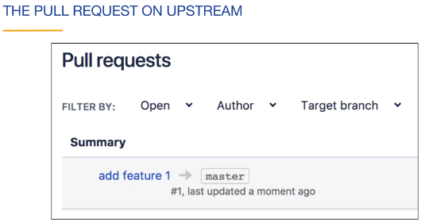

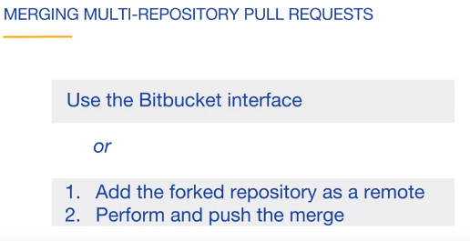

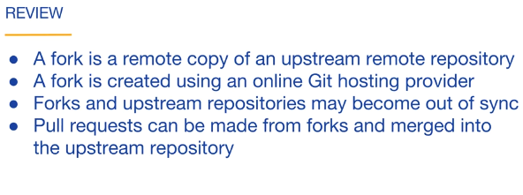

Source tree docx link for this chapter:

<https://d3c33hcgiwev3.cloudfront.net/DBsOFQQBQt-bDhUEAQLffQ_95a3623aa57d40be94f35c5b8be387de_lab3_4_02a_sourcetree_pull_II.pdf?Expires=1593734400&Signature=MEn3QVakFBV2xHXI3aTMAyy6AMZhbeRoyxcEI8AZHGZkvJNAySmDoLMdyK2GLi9X9DF8~QaA5kRNHFDTTkfSsXMmvev6isbznWLoNpsvlwzeLz2PB2bx7ENIMPgKD22x2r9Wa2NLDsAEQheHn6jAxVqDD~TldU~23sL34UfSdsk_&Key-Pair-Id=APKAJLTNE6QMUY6HBC5A>

Command Line docx link for this Chapter:

<https://d3c33hcgiwev3.cloudfront.net/HQ1nzW6eRsSNZ81unqbE4g_a526fbf0a6d2402581d3ec0069f481dc_lab3_4_02b_cli_pull_II.pdf?Expires=1593734400&Signature=I5-7cee~hgMEezaFImH7-rZBpaVMmQuttKocBcG6F5aVRfOuCgpCWz3jQrPhRLNQl30Z-7zdk4sjvWOT69k2pm8HbzYUM8mbDLYzS0rYZQedg4AogMkhMYiyfzQ-yGKc9gz-n1tIZDZg2VrWlTOn7Ow3eej7LuOt2c9WQFFZ~ac_&Key-Pair-Id=APKAJLTNE6QMUY6HBC5A>

**Git Workflows**

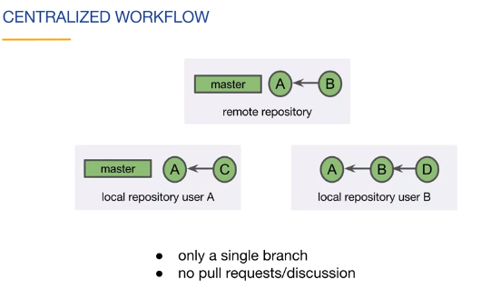

* Which one of these is a disadvantage of a workflow using only the master branch? No pull requests.

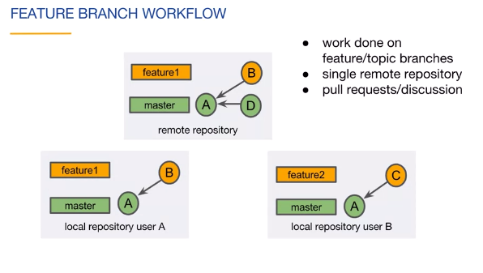

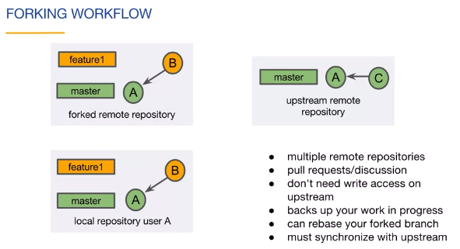

* Which one of the following statements about forking workflows is true?

A person making a pull request does not need write access to the upstream repository.

